1 Introduction:

The management of records in a university is a critical aspect of academic administration, as it involves managing the personal, academic, and administrative information of students, faculty, and staff. In today's digital age, it is essential to have a reliable record management system that can efficiently store, retrieve, and manage data, while also ensuring the security and privacy of sensitive information.

* 1. Project Background.

Our software engineering company has been approached by Dr. Simon White, the course leader of the Computing Degree at Woodlands University College (WUC), with a request to investigate the possibility of developing a computerized course management system. Dr. White has expressed his concern that the current clerical-based system used by the college is not as efficient as it could be, and that a more modern and technologically advanced system is required to manage the courses offered by WUC. We understand that if successful, the software we develop will be used throughout the institution, but initially, we have been asked to produce a pilot system specifically for the computing department.

* 1. Project Aims and Objective

The primary aim of this project is to design and develop a CMS that will meet the needs of both instructors and students. Specifically, our objectives are:

* To create a user-friendly interface for students to access course content, submit assignments, and receive feedback.
* The system should be able to manage all aspects of a course, including:

o Student records

o Staff records

o Course records

o Module management

o Assignment management

o Attendance records

o Personal tutor management

* The system should be scalable to support the growing number of students and courses.
* The system should be extensible to support future changes and requirements.

To complete those aims in an organized manner we first need to fully identify and manage our objectives to fulfill the needs of Dr. White and his concern for WUC. These objectives will be completed in specifical order for more efficient workflow of our team:

* Gain deep understanding of the problem domain.
* Create well designed system specification.
* Design the website interface as per the client requirements.
* Develop the website as per the design.
* Test the website for real time case scenario.
* Evaluate the result and present it to the client.
  1. Project Development Methodology.

To meet our project goals, we will use an agile development methodology. This approach involves developing the product in short iterations with frequent feedback from users and stakeholders. We will start by carefully analyzing user requirements, and then move on to designing, developing, and testing the product. Throughout the process, we will prioritize user feedback and make changes as needed to ensure that the final product meets the needs of our target audience.

**2 Requirement Engineering**

Requirement engineering is a method to define, document and maintain requirements in the engineering design process, understanding what the client wants, evaluating the need, determining viability, negotiating a fair solution, clearly defining the solution, validating the specifications, and monitoring the requirements as they are turned into a functional system are its key goals.

2.1 Elicitation Activities

Elicitations is a process used to assess requirements by spotting errors, flaws, omissions, etc. It focuses on the client’s agreements, the problem domain, and a study of related systems.

2.1.1 Interview plans

Questions:

* **Dr. Simon White:** The computing course leader: -

1. Do you think sudden change from clerically based system to computerized course

management system will affect the student as well as teachers in keeping the

record up to date?

1. Presently, how do you monitor and oversee student enrolment, grades, and course progress?
2. Can you give some examples of instances when a computerized course management system might have been of assistance?
3. What is your budget and timeframe for deploying a computerized course management system?
4. Could you guide us step-by-step in creating and overseeing a course from beginning to end, and how would a computerized course management system fit into this process?
5. What are the key problems that you face when handling courses manually?
6. What outcomes do you envisage from using a digital course management system?
7. What precise training and guidance on how to operate the course management system would be provided to both instructors and learners?
8. Is there further assistance that the course management system requires?
9. Is there any information that should be hidden from the users(students)?

* **Mr. Adam Blake:** An experienced course administrator from the computing course program support team: -

1.What, in your perspective, is the most crucial feature of a computerized course management system for both learners and instructors?

2.How can the course management system assist instructors and learners to analyse data?

3.What varieties of data and understanding may be acquired by employing a course management system, and how can this insight be used to enhance the academic experience at your institute?

4.What real impact does a computerized course management system have on student and instructor interaction and cooperation, and how might this alter the learning experience?

5.In what ways perhaps a course management system assist students create a personalized and stimulating learning environment?

6.What policies or protocols are in place for safeguarding this information, and how does your institution guarantee the confidentiality and safety of the information within the course management system?

7.Which specific design features, in your opinion, would have the greatest impact on enhancing the user experience of the course management system for both learners and instructors, including characteristics such as noticeable characteristic, colour choices, navigation tools, or any other relevant factors?

* **Dr. Raj singh:** A senior lecturer, module leader and personal tutor from the computing department: -

1.As a personal tutor, do you anticipate this course management system will aid academically challenged students?

2.Do you anticipate that a computerized course management system will alter your instructional strategies and course materials?

3.What are the big concerns you have while coordinating courses manually, and how do you think a computerized course management system may assist you overcome these obstacles?

4.What specific requirements or capabilities do you want to see in a computerized course management system that will help you streamline your workflows and optimize your teaching and tutoring endeavours?

5.How do you see leveraging the insights and analytics conceived by a course management system to inform your teaching tactics and adapt to your students' changing needs?

6.How, in your opinion, will the deployment of a computerized course management system influence the broader computing department and its overall approach to education delivery?

7.From your point of view , do you feel that accomplishment of computerized course management system will result in better tracking and analysis of student engagement and performance in a more time-effective manner?

* **Mr. Mark Williams:** An existing student enrolled on the computing course.

1. What concerns did you experience as a student with assessments, results dissemination, and course material under a clerically oriented system?
2. How do you believe the course management system will guarantee your privacy and security?
3. What key characteristics or functionalities do you like to see in this computerized course management system to assist you better manage your assignments and interact with your classmates and instructors?
4. How do you believe a computerized course management system may assist students in your program cooperate and communicate more?
5. How do you consider a course management system may assist your teachers in clearer grasp your learning requirements and customizing their teaching tactics to meet those needs?
6. How do you think the learners will interact to the computerized course management system?
7. Do you assume a computerized course administration system will have an impact on student grading and data handling?

**2.1.2 Interview Findings**

2.1.2.1 Interview Title: Initial Interview with computing course leader- Dr Simon white

Interview Date: 03/07/2023

Duration: 1 hour

Persons in attendance:

Phurbu

Bipin

Anish

Samden

Adarsh

The questions and answers are briefly detailed in table below:

|  |  |  |
| --- | --- | --- |
| Interviewer | Question S.N | Questions and answers |
| phurbu | 1 | Do you think sudden change from clerically based system to computerized course  management system will affect the student as well as teachers in keeping the  record up to date?  Answer: – In the beginning, it’s required to organize training and practice session to educate end users to use the system. It helps to adopt new system in each users day to day operations. Once it’s being adopted, system will obviously deliver the functional modules along with the non-functional requirements such as single source of truth for the information, provide latest information, access control and security in the information, and better user experience. |
| Bipin | 2 | Presently, how do you monitor and oversee student enrolment, grades, and course progress?  Answers: There is no particular system to monitor and oversee enrolment, grades, and course progress. There will be total student pool in a spreadsheet file for the enrolment, grades, and course progress in which filter option to apply for getting oversee student enrolment, grades, and course progress. Also, those records are stored in a printed format for the source of reference. |
| Anish | 3 | Can you give some examples of instances when a computerized course management system might have been of assistance?  Answers: Definitely, computerized course management system might be great assistance in the whole workflow processes as also listed few examples below:  -Learning materials managing, tracking the changes and interaction report.  -Assignment and course progress tracking  -Generate alert notification as required in the different modules, and so on. |
| Samden | 4 | What is your budget and timeframe for deploying a computerized course management system?  Answers: – In reference to timeline, final due date is May 7, 2023 referring the university deadline, however, expected to get the solution in user acceptance test (UAT) at least one prior to the final deadline. In terms of cost, you shall propose multiple cost options with the different quoted price and offering features, so that I will review, negotiate (if required), and pick-up a cost option for the deliverables. |
| Adarsh | 5 | Could you guide us step-by-step in creating and overseeing a course from beginning to end, and how would a computerized course management system fit into this process?  Answers: Ideally, computerized course management system will follow the follow steps:   * Students creates profile * Students apply to a course for the enrolment * Admin will review course application, review the academic and personal details * Admin follow-up to the students if required any documents or follow-up * Admin approve the enrolment to the course * Admin assign tutor and module leader to the module in the course * Tutor/Module leader creates the class * Tutor/Module leader upload the learning materials * Student attend the class * Student will access learning materials * System captures the attendance records * System captures the activities in the access of learning materials * Tutor/Module leader assign assignment * Students access and submit the assignment * Tutor/Module leader grade the assignment and upload the grade to the system * Tutor/Module Leader publish the results * Admin generates the grade sheet and transcript |
| Phurbu | 6 | What are the key problems that you face when handling courses manually?  Answers: Key problems when handling courses manually are listed below:   * Single source of truth for the information * Provide latest information * Access control and security in the information * User experience |
| Bipin | 7 | What outcomes do you envisage from using a digital course management system?  Answers: Functional modules along with the non-functional requirements such as single source of truth for the information, provide latest information, access control and security in the information, and better user experience. |
| Anish | 8 | What precise training and guidance on how to operate the course management system would be provided to both instructors and learners?  Answers: Several hands-on training and development session to be conducted to train all the stakeholders including both instructors and learners so that they will get familiar with the new system and get ready to use the system in their day to day job. Also, it’s required to record video tutorial to educate the functionalities of the new course management system, it helps to learn them in offline. |
| Samden | 9 | Is there further assistance that the course management system requires?  Answers: As mentioned in response to #8, it’s good to draft video tutorials to educate the functionalities of the new system which can further assist learning the system. |
| Adarsh | 10 | Is there any information that should be hidden from the users(students)?  Answers: There are many functionalities and information to be hidden to the students, few details are captured in the following table, similar restrictions to be applied in other functionalities as well.\  Diagram  Description automatically generatedTable  Description automatically generatedDiagram  Description automatically generated |

2.1.2.2 Interview Title: Initial Interview with Mr. Adam Blake: An experienced course administrator from the computing course program support team: -

Interview Date: 03/08/2023

Duration: 1 hour

Persons in attendance:

Phurbu

Bipin

Anish

Samden

Adarsh

The questions and answers are briefly detailed in table below:

|  |  |  |
| --- | --- | --- |
| Interviewer | Question S.N | Question and answers |
| Phurbu | 1 | What, in your perspective, is the most crucial feature of a computerized course management system for both learners and instructors?  Answers: Few most crucial features of course management system for both learners and instructors are listed below:   * Tutor/Module leader creates the class * Tutor/Module leader upload the learning materials * Student attend the class * Student will access learning materials * System captures the attendance records * System captures the activities in the access of learning materials * Tutor/Module leader assign assignment * Students access and submit the assignment * Tutor/Module leader grade the assignment and upload the grade to the system * Tutor/Module Leader publish the results |
| Bipin | 2 | How can the course management system assist instructors and learners to analyse data?  Answers: – Course management system will provide fully automated functionalities and keep tracking all the events and activities which avail data for further analysis. |
| Anish | 3 | What varieties of data and understanding may be acquired by employing a course management system, and how can this insight be used to enhance the academic experience at your institute?  Answers: Certainly, new course management system captures resource access information log which can be presented in the form of insights report and it can be uses to enhance the academic experience. |
| Samden | 4 | What real impact does a computerized course management system have on student and instructor interaction and cooperation, and how might this alter the learning experience?  Answers: New system delivers all the functional requirements and also ensure single source of truth for the information, provide latest information, access control and security in the information, and better user experience which will be a real impact of the system implementation in the university. |
| Adarsh | 5 | In what ways perhaps a course management system assist students create a personalized and stimulating learning environment?  Answers: New course management system would provide features access, tracking the information, and see all the academic progress such as learning materials access, assignments submission, grading of the assignments, attendance tracking, academic report card in a personalized manner which creates enhanced learning experience in the university. |
| Phurbu | 6 | What policies or protocols are in place for safeguarding this information, and how does your institution guarantee the confidentiality and safety of the information within the course management system?  Answers: Following protocol and practices will ensure safeguarding the information in new system:   * Each user role will have access to the information which is most required for his role * Logging each events and activities in the application * Comply system design and implementation with data privacy act like GDPR (General Data Protection Regulation) |
| Bipin | 7 | Which specific design features, in your opinion, would have the greatest impact on enhancing the user experience of the course management system for both learners and instructors, including characteristics such as noticeable characteristic, colour choices, navigation tools, or any other relevant factors?  Answers: considering the May 7, 2023 deliverables, you shall take Northampton university website for all requirements mentioned above. |

2.1.2.3 Interview Title: Initial Interview with Dr. Raj singh: A senior lecturer, module leader and personal tutor from the computing department: -

Interview Date: 03/09/2023

Duration: 1 hour

Persons in attendance:

Phurbu

Bipin

Anish

Samden

Adarsh

The questions and answers are briefly detailed in table below:

|  |  |  |
| --- | --- | --- |
| Interviewer | Question S.N | Questions and answers |
| Phurbu | 1 | As a personal tutor, do you anticipate this course management system will aid academically challenged students?  Answers: Certainly new system will challenge students by tracking learning material access, assignment progress tracking, checking uniqueness and plagiarism of the work, and many more will aid academically challenged students. |
| Bipin | 2 | Do you anticipate that a computerized course management system will alter your instructional strategies and course materials?  Answers: – Ideal workflow of instructional strategies and course materials will not change, however, additional avenue shall be introduced as new course management system offers features. |
| Anish | 3 | What are the big concerns you have while coordinating courses manually, and how do you think a computerized course management system may assist you overcome these obstacles?  Answers: – Computerized course management system helps ensuring single source of truth for the information, provide latest information, access control and security in the information, and better user experience. |
| Samden | 4 | What specific requirements or capabilities do you want to see in a computerized course management system that will help you streamline your workflows and optimize your teaching and tutoring endeavours?  Answers: - Few most crucial features of course management system for both learners and instructors are listed below:   * Tutor/Module leader creates the class * Tutor/Module leader upload the learning materials * Student attend the class * Student will access learning materials * System captures the attendance records * System captures the activities in the access of learning materials * Tutor/Module leader assign assignment * Students access and submit the assignment * Tutor/Module leader grade the assignment and upload the grade to the system * Tutor/Module Leader publish the results |
| Adarsh | 5 | How do you see leveraging the insights and analytics conceived by a course management system to inform your teaching tactics and adapt to your students' changing needs?  Answers: Certainly, new course management system captures resource access information log which can be presented in the form of insights report and it can be uses to enhance teaching tactics and adapt to changing need. |
| Phurbu | 6 | How, in your opinion, will the deployment of a computerized course management system influence the broader computing department and its overall approach to education delivery?  Answers: Course management system helps ensuring single source of truth for the information, provide latest information, access control and security in the information, and better user experience, and deliver the functional modules through which department enhances overall administrative and academic qualities in the university. |
| Bipin | 7 | From your point of view , do you feel that accomplishment of computerized course management system will result in better tracking and analysis of student engagement and performance in a more time-effective manner?  Answers: From your point of view , do you feel that accomplishment of computerized course management system will result in better tracking and analysis of student engagement and performance in a more time-effective manner? |

2.1.2.4 Interview Title: Initial Interview with Mr. Mark Williams: An existing student enrolled on the computing course.

Interview Date: 03/10/2023

Duration: 1 hour

Persons in attendance:

Phurbu

Bipin

Anish

Samden

Adarsh

The questions and answers are briefly detailed in table below:

|  |  |  |
| --- | --- | --- |
| Interviewer | Question S.N | Question and answers |
| phurbu | 1 | What concerns did you experience as a student with assessments, results dissemination, and course material under a clerically oriented system?  Answers: Current clearical system having very bad user experience, it has lack of centralized solution, access to latest information, lengthy process to get information, etc. |
| Bipin | 2 | How do you believe the course management system will guarantee your privacy and security?  Answers: Following protocol and practices will ensure guarantee privacy and security:   * Each user role will have access to the information which is most required for his role * Logging each events and activities in the application * Comply system design and implementation with data privacy act like GDPR (General Data Protection Regulation) |
| Anish | 3 | What key characteristics or functionalities do you like to see in this computerized course management system to assist you better manage your assignments and interact with your classmates and instructors?  Answers: Few most crucial characteristics of course management system are listed below:   * Student attend the class * Student will access learning materials * System captures the attendance records * System captures the activities in the access of learning materials * Student submit question/queries to another classmates personally or group of students or instructors personally, and receive the response accordingly * Students access and submit the assignment |
| Samden | 4 | How do you believe a computerized course management system may assist students in your program cooperate and communicate more?  Answers: There will be communication functionality too which includes student submit question/queries to another classmates personally or group of students or instructors personally, and receive the response accordingly. It enhances students communicating and cooperate in a program in a effective way. |
| Adarsh | 5 | How do you consider a course management system may assist your teachers in clearer grasp your learning requirements and customizing their teaching tactics to meet those needs?  Answers: In addition to the question and queries students can communicate to their classmates and instructors, there will be mechanism to share feedback to the instructor so that instructor also can change teaching tactics for better learning environment. |
| Phurbu | 6 | How do you think the learners will interact to the computerized course management system?  Answers: In addition to the question and queries students can communicate to their classmates and instructors, there will be mechanism to share feedback to the instructor so that instructor also can change teaching tactics for better learning environment. |
| Bipin | 7 | Do you assume a computerized course administration system will have an impact on student grading and data handling?  Answers: Certainly, new system will have sufficient features in student assignment grading and data handling, so that admin can track academic progress, generate grade report, tracing any information change, etc. |

2.1.3 Other problem domain research

2.1.3.1 Comparable Software System Review

Following are some comparable software reviews:

2.1.3.1.2 Student Records/Information Portals

**1. Blackboard Learn**

Before beginning the main sections of the problem domain investigation, it is first important to gain a better understanding of the current website and its problems. A heuristic evaluation has been done on Blackboard Learn to get a briefer understanding of current design patterns and trends.

Conformity Key

1 = Conforms in all parts.

2 = Conforms in most parts.

3 = Conforms in some parts.

4 = Does not conform.

|  |  |  |  |
| --- | --- | --- | --- |
| **Usability Criteria (Heuristics) Appropriate Use of:** | **Level of Conformity**  **(1-4)** | **Evidence/Examples of Application** | **Additional Comments/Issues Raised** |
| **Consistency in Design** | 2 | All designs are consistent throughout the site. | It lacks some coloring most of the page is white colored |
| **Visibility of System Status** | 1 | Provide clear and consistent feedback to users on the status of their actions. | Uses visual cues to indicate the current state of a task, such as progress bars or loading animations. |
| **Error Prevention** | 1 | Validates user Input every time. | Uses clear error message to notify the user. |
| **Icons** | 1 | Icons are well aligned and well presented | No comments for icons. |
| **Response Time** | 2 | User response time is quite slow | When user clicks on any option it takes quite some time to load the content. |
| **Buttons** | 1 | Buttons are well placed and organized. |  |
| **Flexibility and ease of use** | 3 | The site can be easily used by people of any age group | The site lacks functionality for differently abled students/teacher |

**2. Canvas Student**

A heuristic evaluation has been done on Canvas Student to get a briefer understanding of current design patterns and trends.

Conformity Key

1 = Conforms in all parts.

2 = Conforms in most parts.

3 = Conforms in some parts.

4 = Does not conform.

|  |  |  |  |
| --- | --- | --- | --- |
| **Usability Criteria (Heuristics) Appropriate Use of:** | **Level of Conformity**  **(1-4)** | **Evidence/Examples of Application** | **Additional Comments/Issues Raised** |
| **Consistency in Design** | 2 | All designs are consistent throughout the site. | It has bright colors which can be inconvenient for some users. It also has lots of wide empty space |
| **Visibility of System Status** | 1 | Provide clear and consistent feedback to users on the status of their actions. | Tooltip is implemented to give user overview about the status |
| **Error Prevention** | 1 | Validates user Input every time. | Uses clear error message to notify the user. |
| **Icons** | 1 | Icons are well aligned and well presented | No comments for icons. |
| **Response Time** | 2 | User response time good | Takes some time while loading the data. |
| **Buttons** | 1 | Buttons are well placed and organized. |  |
| **Flexibility and ease of use** | 3 | The site can be easily used by people of any age group. This also has customization feature | The site lacks functionality for differently abled students/teacher |

2.1.3.1.1 Records Management System.

**1. Nuxeo**

A heuristic evaluation has been done on Nuxeo to get a briefer understanding of current design patterns and trends.

Conformity Key

1 = Conforms in all parts.

2 = Conforms in most parts.

3 = Conforms in some parts.

4 = Does not conform.

|  |  |  |  |
| --- | --- | --- | --- |
| **Usability Criteria (Heuristics) Appropriate Use of:** | **Level of Conformity**  **(1-4)** | **Evidence/Examples of Application** | **Additional Comments/Issues Raised** |
| **Consistency in Design** | 1 | Minimalistic design followed throughout page. | All items are well placed |
| **Visibility of System Status** | 2 | Provide clear and consistent feedback to users on the status of their actions. |  |
| **Error Prevention** | 1 | Validates user Input every time. | Uses clear error message to notify the user. |
| **Icons** | 1 | Icons are well aligned and well presented | . |
| **Response Time** | 2 | User response time good |  |
| **Buttons** | 1 | Buttons are well placed and organized. |  |
| **Flexibility and ease of use** | 2 | Site has too many options and can be confusing sometimes. | The site lacks functionality for differently abled students/teacher |

**2. Folderit**

A heuristic evaluation has been done on Folderit to get a briefer understanding of current design patterns and trends.

Conformity Key

1 = Conforms in all parts.

2 = Conforms in most parts.

3 = Conforms in some parts.

4 = Does not conform.

|  |  |  |  |
| --- | --- | --- | --- |
| **Usability Criteria (Heuristics) Appropriate Use of:** | **Level of Conformity**  **(1-4)** | **Evidence/Examples of Application** | **Additional Comments/Issues Raised** |
| **Consistency in Design** | 2 | Slightly inconsistent design in all pages |  |
| **Visibility of System Status** | 2 |  | No tooltip or hoover highlight in option so it is hard to navigate for user. |
| **Error Prevention** | 1 | Validates user Input every time. | Uses clear error message to notify the user. |
| **Icons** | 1 | Icons are well aligned and well presented | . |
| **Response Time** | 2 | Response time is comparatively slow | While going to new page it takes quite a few time. |
| **Buttons** | 1 | Buttons are well placed and organized. |  |
| **Flexibility and ease of use** | 2 |  | The site lacks functionality for differently abled students/teacher |

2.1.3.1.3 University/HE Websites

**1. University of Northampton**

A heuristic evaluation has been done on University of Northampton to get a briefer understanding of current design patterns and trends.

Conformity Key

1 = Conforms in all parts.

2 = Conforms in most parts.

3 = Conforms in some parts.

4 = Does not conform.

|  |  |  |  |
| --- | --- | --- | --- |
| **Usability Criteria (Heuristics) Appropriate Use of:** | **Level of Conformity**  **(1-4)** | **Evidence/Examples of Application** | **Additional Comments/Issues Raised** |
| **Accuracy** | 1 | The information on the page are authentic and accurate. |  |
| **Clarity** | 2 | Information are clearly given | There might be too much information which can be confusing to users |
| **Error Prevention** | 1 | Validates user Input every time. | Uses clear error message to notify the user. |
| **Consistency and standard** | 1 | The design in sites is consistent | . |
| **User control and freedom** | 2 | Site allows user to correct their error. | Well descriptive delete button or canceling an action. |
| **Response time** | 3 | User response time is slow | The images and JavaScript of site loads quite slow |
| **Flexibility and ease of use** | 2 |  | The site lacks functionality for differently abled students/teacher |

**2. University of California**

A heuristic evaluation has been done on University of California to get a briefer understanding of current design patterns and trends.

Conformity Key

1 = Conforms in all parts.

2 = Conforms in most parts.

3 = Conforms in some parts.

4 = Does not conform.

|  |  |  |  |
| --- | --- | --- | --- |
| **Usability Criteria (Heuristics) Appropriate Use of:** | **Level of Conformity**  **(1-4)** | **Evidence/Examples of Application** | **Additional Comments/Issues Raised** |
| **Accuracy** | 1 | The information on the page is authentic and accurate. |  |
| **Clarity** | 3 | There is news in the homepage which can be distracting | Since it’s a university website, news about university would be more appropriate |
| **Error Prevention** | 1 | Validates user Input every time. | Uses clear error message to notify the user. |
| **Consistency and standard** | 3 | The design seems very outdated. | . Consistency is not followed |
| **User control and freedom** | 2 | Site allows user to correct their error. | Well descriptive delete button or canceling an action. |
| **Response time** | 3 | Response time is average. |  |
| **Flexibility and ease of use** | 2 | Site has too many options and can be confusing sometimes | The site lacks functionality for differently abled students/teacher |

2.1.3.1.4 Mobile Application-Based Student Information Systems.

**1. Blackboard Learn**

A heuristic evaluation has been done on Blackboard Learn mobile application to get a briefer understanding of current design patterns and trends.

Conformity Key

1 = Conforms in all parts.

2 = Conforms in most parts.

3 = Conforms in some parts.

4 = Does not conform.

|  |  |  |  |
| --- | --- | --- | --- |
| **Usability Criteria (Heuristics) Appropriate Use of:** | **Level of Conformity**  **(1-4)** | **Evidence/Examples of Application** | **Additional Comments/Issues Raised** |
| **Visibility of system status** | 1 | App navigates the user well. |  |
| **Consistency and standards** | 1 | Design is constant and aesthetic for all activity |  |
| **Error Prevention** | 1 | Validates user Input every time. | Uses clear error message to notify the user. |
| **Flexibility and efficiency of use** | 2 | The app is flexible for all age group users. | The loading speed is a bit slow. |
| **Help users recognize, diagnose, and recover from errors** | 2 | Site allows user to correct their error. | Well descriptive delete button or canceling an action. |
| **Safety** | 1 | The app is very secure and does not contain any malicious code. |  |
| **Simplicity** | 2 | Site is easy to user for all age group. |  |

**2. Canvas Student**

A heuristic evaluation has been done on Canvas Student mobile application to get a briefer understanding of current design patterns and trends.

Conformity Key

1 = Conforms in all parts.

2 = Conforms in most parts.

3 = Conforms in some parts.

4 = Does not conform.

|  |  |  |  |
| --- | --- | --- | --- |
| **Usability Criteria (Heuristics) Appropriate Use of:** | **Level of Conformity**  **(1-4)** | **Evidence/Examples of Application** | **Additional Comments/Issues Raised** |
| **Visibility of system status** | 1 | App navigates the user well. |  |
| **Consistency and standards** | 3 | Design is constant and aesthetic for all activity | Color combination do not match as website |
| **Error Prevention** | 1 | Validates user Input every time. | Uses clear error message to notify the user. |
| **Flexibility and efficiency of use** | 2 | The app is flexible for all age group users. | Lacks dark mode |
| **Help users recognize, diagnose, and recover from errors** | 2 | Site allows user to correct their error. | Well descriptive delete button or canceling an action. |
| **Safety** | 1 | The app is very secure and does not contain any malicious code. |  |
| **Simplicity** | 1 | Site is easy to user for all age group. | It also has a chat feature to contact your tutors. |

2.1.3.2 Development Relevant Legislation

**Equality Act:**

The Equality Act 2010 is an important piece of legislation that prohibits discrimination, harassment, and victimization on the basis of nine protected characteristics, which are age, disability, gender reassignment, marriage and civil partnership, pregnancy and maternity, race, religion or belief, sex, and sexual orientation. It applies to all areas of education, including schools, universities, and other educational institutions.

**General Data Protection Regulation (GDPR):**

The GDPR is a regulation that governs the collection, use, and storage of personal data by businesses and organizations. It came into effect in May 2018 and applies to all organizations that process personal data of individuals in the EU, including educational institutions. The GDPR requires organizations to obtain explicit consent from individuals before collecting their personal data, ensure that personal data is accurate and up-to-date, and implement appropriate security measures to protect personal data.

**Educational Relevant Legislation:**

There are several pieces of legislation that are relevant to education in the UK, including:

**Education Act 1996:** This act sets out the legal framework for the provision of education in England and Wales. It covers areas such as the duties of local authorities to provide education, the curriculum, and the inspection of schools.

**Children and Families Act 2014:** This act introduces a range of reforms to the provision of support for children and young people with special educational needs and disabilities (SEND). It includes provisions for the identification of children with SEND, the creation of Education, Health and Care Plans, and the provision of support in schools.

**Higher Education and Research Act 2017:** This act provides the legal framework for the provision of higher education in England. It covers areas such as the regulation of higher education providers, the establishment of the Office for Students, and the provision of student loans.

**2.1.3.4 User group Questionnaires**

Student experience questionnaire

|  |  |  |  |  |  |  |  |  |  |  |
| --- | --- | --- | --- | --- | --- | --- | --- | --- | --- | --- |
| NO. | Survey question | Daily | weekly | rarely | monthly | yes | no | important | neutral | Comments/feedback |
| 1 | How commonly do you use your degree program's current course management system? |  |  |  |  |  |  |  |  |  |
| 2 | What key characteristics do you want to see in a new computerized course administration system for your computer degree program? |  |  |  |  |  |  |  |  | . |
| 3 | Do you find the existing course management system for your computing degree program to be user-friendly? |  |  |  |  |  |  |  |  |  |
| 4 | What aspects of the current course management system for your computing degree program could, in your view, be improved? |  |  |  |  |  |  |  |  |  |
| 5 | How crucial is mobile device compatibility for the new course administration system? |  |  |  |  |  |  |  |  |  |
| 6 | Would you like to see a feature for real-time collaboration with classmates and instructors in the new course management system? |  |  |  |  |  |  |  |  |  |
| 7 | What kinds of assessments would you like to see in your computing degree program's new course administration system? |  |  |  |  |  |  |  |  |  |
| 8 | How crucial is it that the new course management system integrate with other software systems employed in your school (like virtual machines, coding tools, etc.)? |  |  |  |  |  |  |  |  |  |
| 9 | How crucial is it that the new course administration system has a customized dashboard that shows pertinent data unique to your computing degree program? |  |  |  |  |  |  |  |  |  |
| 10 | Would you like a tool that allows you to create custom notifications and reminders for forthcoming assignments and exams in the new course management system? |  |  |  |  |  |  |  |  |  |

Student experience questionnaires Results(Student 1)

|  |  |  |  |  |  |  |  |  |  |  |
| --- | --- | --- | --- | --- | --- | --- | --- | --- | --- | --- |
| NO. | Survey question | Daily | weekly | rarely | monthly | yes | no | Important | neutral | Comments/feedback |
| 1 | How commonly do you use your degree program's current course management system? | ☑ |  |  |  |  |  |  |  |  |
| 2 | What key characteristics do you want to see in a new computerized course administration system for your computer degree program? |  |  |  |  |  |  |  |  | The website must be well responsive for the computer degree. |
| 3 | Do you find the existing course management system for your computing degree program to be user-friendly? |  |  |  |  | ☑ |  |  |  |  |
| 4 | What aspects of the current course management system for your computing degree program could, in your view, be improved? |  |  |  |  |  |  |  |  | A more up-to-date and user-friendly interface is needed for the current system, which is cumbersome and out of date. |
| 5 | How crucial is mobile device compatibility for the new course administration system? |  |  |  |  |  |  | ☑ |  |  |
| 6 | Would you like to see a feature for real-time collaboration with classmates and instructors in the new course management system? |  |  |  |  | ☑ |  |  |  |  |
| 7 | What kinds of assessments would you like to see in your computing degree program's new course administration system? |  |  |  |  |  |  |  |  | Individual assignments graded using rubrics |
| 8 | How crucial is it that the new course management system integrate with other software systems employed in your school (like virtual machines, coding tools, etc.)? |  |  |  |  |  |  |  | ☑ |  |
| 9 | How crucial is it that the new course administration system has a customized dashboard that shows pertinent data unique to your computing degree program? |  |  |  |  |  |  | ☑ |  |  |
| 10 | Would you like a tool that allows you to create custom notifications and reminders for forthcoming assignments and exams in the new course management system? |  |  |  |  | ☑ |  |  |  |  |

Student experience questionnaires Results(Student 2)

|  |  |  |  |  |  |  |  |  |  |  |
| --- | --- | --- | --- | --- | --- | --- | --- | --- | --- | --- |
| NO. | Survey question | Daily | weekly | rarely | monthly | yes | no | Important | neutral | Comments/feedback |
| 1 | How commonly do you use your degree program's current course management system? |  | ☑ |  |  |  |  |  |  |  |
| 2 | What key characteristics do you want to see in a new computerized course administration system for your computer degree program? |  |  |  |  |  |  |  |  | System integration with other software |
| 3 | Do you find the existing course management system for your computing degree program to be user-friendly? |  |  |  |  |  | ☑ |  |  |  |
| 4 | What aspects of the current course management system for your computing degree program could, in your view, be improved? |  |  |  |  |  |  |  |  | Online and distance learning support could be enhanced by the system. |
| 5 | How crucial is mobile device compatibility for the new course administration system? |  |  |  |  |  |  |  | ☑ |  |
| 6 | Would you like to see a feature for real-time collaboration with classmates and instructors in the new course management system? |  |  |  |  |  | ☑ |  |  |  |
| 7 | What kinds of assessments would you like to see in your computing degree program's new course administration system? |  |  |  |  |  |  |  |  | introductions and addresses that test correspondence and public abilities to talk. |
| 8 | How crucial is it that the new course management system integrate with other software systems employed in your school (like virtual machines, coding tools, etc.)? |  |  |  |  |  |  |  |  | Not at all |
| 9 | How crucial is it that the new course administration system has a customized dashboard that shows pertinent data unique to your computing degree program? |  |  |  |  |  |  |  | ☑ |  |
| 10 | Would you like a tool that allows you to create custom notifications and reminders for forthcoming assignments and exams in the new course management system? |  |  |  |  |  | ☑ |  |  |  |

**Questionnaire Analysis**

The two students' answers suggest that they both frequently use the current course management system and that they both value a system that is user-friendly and integrates well with other software systems. Both students place a high value on real-time interaction with teachers and peers as well as displays that are specifically designed to display information relevant to their degree programs. They do, however, have slightly different views on the issue of mobile device compatibility, with one student saying it's critical and the other remaining unconcerned. The system should, in the opinion of one student, also include tests of communication and public speaking abilities, while the other student does not express a preference for any particular form of evaluation. Unlike the other student, who does not note the need for online and distance learning support. Overall, it appears from the answers that students desire a system that is simple to use, easily integrated with other programs, and offers chances for collaboration and personalized feedback.

**Academic staff Questionnaires**

|  |  |  |  |  |  |  |  |  |  |  |
| --- | --- | --- | --- | --- | --- | --- | --- | --- | --- | --- |
| No. | Questions | yes | no | Daily | Weekly | Monthly | Rarely | Open end response | Very important | Not very important |
| 1 | How often do you utilize the existing learning management system for the computing degree program? |  |  |  |  |  |  |  |  |  |
| 2 | Which essential features are you looking for in a new computerized course management system for the computer science degree program? |  |  |  |  |  |  |  |  |  |
| 3 | What changes could be made, in your view, to the current course management system for the computing degree program? |  |  |  |  |  |  |  |  |  |
| 4 | How critical is it that your courses' grading and student achievement tracking be handled by the new course management system? |  |  |  |  |  |  |  |  |  |
| 5 | How crucial is it that the new course administration system can handle managing course availability and scheduling? |  |  |  |  |  |  |  |  |  |
| 6 | Would you like to see a tool in the new course management system that allows for real-time collaboration with coworkers and students? |  |  |  |  |  |  |  |  |  |
| 7 | How crucial is it that the new course administration system work with other software systems that are used in the curriculum (like virtual machines, coding tools, etc.)? |  |  |  |  |  |  |  |  |  |
| 8 | Do you face any particular difficulties or worries when using a computerized course administration system? What are they if so? |  |  |  |  |  |  |  |  |  |
| 9 | In your opinion, what benefits would a computerized course management system offer over your current methods? |  |  |  |  |  |  |  |  |  |

**Academic staff Academic staff Questionnaires Results (Teacher1)**

|  |  |  |  |  |  |  |  |  |  |  |
| --- | --- | --- | --- | --- | --- | --- | --- | --- | --- | --- |
| No. | Questions | yes | no | Daily | Weekly | Monthly | Rarely | Open end response | Very important | Not very important |
| 1 | How often do you utilize the existing learning management system for the computing degree program? |  |  | ☑ |  |  |  |  |  |  |
| 2 | Which essential features are you looking for in a new computerized course management system for the computer science degree program? |  |  |  |  |  |  |  |  | Customized dashboards, notices, and informing |
| 3 | What changes could be made, in your view, to the current course management system for the computing degree program? |  |  |  |  |  |  |  |  | Adding participation and support tracking |
| 4 | How critical is it that your courses' grading and student achievement tracking be handled by the new course management system? |  |  |  |  |  |  |  |  | Not at all critical |
| 5 | How crucial is it that the new course administration system can handle managing course availability and scheduling? |  |  |  |  |  |  |  |  | Neutral |
| 6 | Would you like to see a tool in the new course management system that allows for real-time collaboration with coworkers and students? | ☑ |  |  |  |  |  |  |  |  |
| 7 | How crucial is it that the new course administration system work with other software systems that are used in the curriculum (like virtual machines, coding tools, etc.)? |  |  |  |  |  |  |  |  | Extremely crucial |
| 8 | Do you face any particular difficulties or worries when using a computerized course administration system? What are they if so? |  |  |  |  |  |  |  |  | security and privacy concerns regarding data |
| 9 | In your opinion, what benefits would a computerized course management system offer over your current methods? |  |  |  |  |  |  |  |  | Time savings and increased efficiency for both students and teachers |

**Academic staff Questionnaires Results (Teacher2)**

|  |  |  |  |  |  |  |  |  |  |  |
| --- | --- | --- | --- | --- | --- | --- | --- | --- | --- | --- |
| No. | Questions | yes | no | Daily | Weekly | Monthly | Rarely | Open end response | Very important | Not very important |
| 1 | How often do you utilize the existing learning management system for the computing degree program? |  |  |  | ☑ |  |  |  |  |  |
| 2 | Which essential features are you looking for in a new computerized course management system for the computer science degree program? |  |  |  |  |  |  |  |  | robust tools for managing course availability and scheduling. |
| 3 | What changes could be made, in your view, to the current course management system for the computing degree program? |  |  |  |  |  |  |  |  | streamlined procedures for course scheduling and enrollment |
| 4 | How critical is it that your courses' grading and student achievement tracking be handled by the new course management system? |  |  |  |  |  |  |  |  | critical |
| 5 | How crucial is it that the new course administration system can handle managing course availability and scheduling? |  |  |  |  |  |  |  |  | Very crucial |
| 6 | Would you like to see a tool in the new course management system that allows for real-time collaboration with coworkers and students? | ☑ |  |  |  |  |  |  |  |  |
| 7 | How crucial is it that the new course administration system work with other software systems that are used in the curriculum (like virtual machines, coding tools, etc.)? |  |  |  |  |  |  |  |  | Not at all crucial |
| 8 | Do you face any particular difficulties or worries when using a computerized course administration system? What are they if so? |  | ☑ |  |  |  |  |  |  |  |
| 9 | In your opinion, what benefits would a computerized course management system offer over your current methods? |  |  |  |  |  |  |  |  | Instructors could use the system's data analysis tools to monitor students' progress and pinpoint areas where they might require additional resources or support. |

**Questionnaire Analysis**

According to survey answers from academic staff, the majority of them regularly use the current learning management system. A new course management system should have customizable dashboards, notices, and informing capabilities. Adding participation and support tracking to the existing system was proposed as a potential improvement. The tracking of pupil achievement and grading for the courses were also noted as not being important. The significance of controlling class access and scheduling was unimportant. A feature that was deemed desirable was real-time collaboration with colleagues and students. It was also noted that compatibility with other software systems used in the curriculum was essential for the new course administration system. Concerns about privacy and security data were cited as challenges or concerns with using an automated course management system. For both students and instructors, the advantages of a computerized course management system included time savings and increased productivity.

2.2 Requirements Specification

In software engineering, the requirements specification is a critical document that outlines the functional and non-functional requirements of a software system. It provides a clear and concise description of what the system should do, how it should behave, and what it should look like.

2.2.1 Problem Domain Description

2.2.1.1 Existing Business Operation

**2.2.1.1.1 Student Life Cycle.**

The above flowchart outlines the current student lifecycle at the college. It begins with the admission process, followed by enrollment and an orientation program. Classes then commence and students are given assignments, which are evaluated, and the results are released. If the student passes, they proceed to the next semester and the cycle repeats. However, if the student fails, they must re-take the examination until they pass the module. Once all the semesters are completed, the student graduates.

**2.2.1.1.2 Personal Tutorial Lifecycle**

The Personal Tutorial lifecycle at the college begins with the assignment of a tutor to a student. The tutor then takes classes with the student for several weeks, after which an examination is conducted. Once the examination is completed, the tutor evaluates the student's grade and records it both in a spreadsheet and in a printed format, in line with the current practices of the college. The grade is then published to the student in a printed format, and the student receives feedback from the tutor. The process then starts again with further classes and another examination.

2.2.1.2 Summary of existing business limitations requiring resolution and existing strengths.

Summary of Existing Business Limitations Requiring Resolution:

**Inadequate record-keeping:**

The existing approach of maintaining student records and other vital papers, which relies on spreadsheets and manual filing systems, is inefficient. This can cause mistakes and delays while attempting to retrieve crucial information when required.

**Lack of automation:**

The university's current processes are largely manual and paper-based, which can be time-consuming and error-prone. The university could automate some of its processes, such as the processing of student transcripts or the submission of financial aid applications, to reduce time and effort and the risk of errors.

**Limited accessibility:**

There may be hurdles to learning and engagement for students with disabilities due to the university's current systems and procedures. By offering alternative document formats, such large print or Braille, as well as accessible technologies, like screen readers, the institution could improve the accessibility of its systems and procedures.

**Inconsistent student experience:**

The student experience may vary depending on whether all teachers follow the university's current personal tutorial lifecycle. To guarantee that all students have a consistent experience, the university might standardize the personal tutorial lifecycle by creating a set of rules and procedures that all tutors would be expected to follow.

**Existing Strengths:**

**Experienced faculty:**

Woodland University College has a group of knowledgeable faculty members who have years of experience teaching. They are committed to assisting pupils in succeeding and have a strong enthusiasm for teaching.

**Student-focused approach:**

The university is dedicated to giving students a top-notch education. This indicates that the emphasis is on assisting each student in achieving their own objectives. The university provides a range of assistance programs to aid students in succeeding, including career services, counseling, and tutoring.

**Established reputation:**

The University College has an excellent standing in the neighborhood. Successful graduates from the college have a history of having successful careers.

2.2.2 Functional Requirement

Here are some functional requirements that we have found through client interaction:

2.2.2.1.1 Records Management Systems

Below table briefly demonstrates the functional requirement for Record management system.

|  |  |  |  |
| --- | --- | --- | --- |
| Operations | Administrator | Lecturer | Student |
| Create | Create new admission | No Access | No Access |
| Update | Can update the admission | No Access | No Access |
| Delete/Archive | Can delete/archive admission | No Access | No Access |
| Display | All the admission | Their assigned students | Their information |
| Assign | Lecturer to student | Can view student | No Access |

|  |  |  |  |
| --- | --- | --- | --- |
| Operations | Administrator | Lecturer | Student |
| Create | Create new Course | No Access | No Access |
| Update | Can update the course | No Access | No Access |
| Delete/Archive | Can delete/archive course | No Access | No Access |
| Display | All the courses | Courses they teach | Courses They have taken |
| Assign | Courses to teacher and student | No Access | No Access |
| Operations | Administrator | Lecturer | Student |
| Create | Can create attendance record | No Access | No Access |
| Update | Can update the attendance record | Update the attendace | No Access |
| Delete/Archive | Can delete/archive attendance | No Access | No Access |
| Display | All attendance | Attendance of their students | Attendance of themselves only |
| Assign | Attendance access to lecturer | No Access | No Access |

2.1.3.1.2 Student Records/Information Portal

Below table briefly demonstrates the functional requirement for Student Records/Information Portal.

|  |  |  |  |
| --- | --- | --- | --- |
| Operations | Administrator | Lecturer | Student |
| Create | Can create student account | No Access | No Access |
| Update | Can update the students account | No Access | No Access |
| Delete/Archive | Can delete/archive student account | No Access | No Access |
| Display | All students | Can view their student | Can view their account |
| Assign | Assign personal tutor to students | No Access | No Access |

|  |  |  |  |
| --- | --- | --- | --- |
| Operations | Administrator | Lecturer | Student |
| Create | Can mark grades | Can mark student grades | No Access |
| Update | Can update the student’s grade | Can update their student’s grade | No Access |
| Delete/Archive | Can delete/archive student account | No Access | No Access |
| Display | All students grade | Can view their student’s grade | Can view their grade |
| Assign | Assign grade to student | Assign feedback for grades | No Access |

2.1.3.1.3 Woodlands University College Corporate Website

Below table briefly demonstrates the functional requirement for Woodlands University College Corporate Website.

|  |  |  |  |
| --- | --- | --- | --- |
| Operations | Administrator | Lecturer | Student |
| Create | Can create Content for website | No Access | No Access |
| Update | Can update the content of website | No Access | No Access |
| Delete/Archive | Can delete/archive content of website | No Access | No Access |
| Display | Full website with admin control | Only readable website | Only readable website |
| Assign | Access to new admin | No access | No Access |

2.2.3 Performance Requirements

2.2.3.1 Records Management

**2.2.3.1.1 Speed**

* The system must be able to retrieve records quickly and efficiently. The system should be able to search for records by keyword, date, or other criteria.
* The system should also be able to provide a preview of records before they are opened.

**2.2.3.1.2 Capacity**

* The system must be able to store a large number of records. The system should be able to handle both current and historical records.
* The system should also be able to handle different types of records, such as documents, images, and videos.

**2.2.3.1.3 Reliability**

* The system must be reliable and should not crash or lose data.
* The system should be backed up regularly and should be able to recover from crashes.
* The system should also be secure and should protect records from unauthorized access.

**2.2.3.1.4 Usability**

* The system must be easy to use and should not require extensive training.
* The system should have a user-friendly interface and should be intuitive to use.
* The system should also be accessible to users with disabilities.

**2.2.3.1.5 Accessibility**

* The system must be accessible to users with disabilities.
* The system should be able to be used by users who are blind, deaf, or have other disabilities.
* The system should also be able to be used by users who use assistive technologies, such as screen readers and Braille displays.
* The performance requirements for a records management system are important to ensure that the system meets the needs of the organization.
* The system must be able to store a large number of records, retrieve records quickly and efficiently, be reliable, and be easy to use.
* The system must also be accessible to users with disabilities.

**2.2.3.2 Student Records/Information Portal**

**2.2.3.2.1 Speed**

* The Student Records/Information Portal must be able to retrieve student records quickly and efficiently.
* The system should be able to search for records by keyword, date, or other criteria.
* The system should also be able to provide a preview of records before they are opened.

**2.2.3.2.2 Capacity**

* The Student Records/Information Portal must be able to store many student records.
* The system should be able to handle both current and historical records.
* The system should also be able to handle different types of records, such as documents, images, and videos.

**2.2.3.2.3 Reliability**

* The Student Records/Information Portal must be reliable and should not crash or lose data.
* The system will be backed up regularly and should be able to recover from crashes.
* The system should also be secure and should protect student records from unauthorized access.

**2.2.3.2.4 Usability**

* The Student Records/Information Portal must be easy to use and should not require extensive training.
* The system should have a user-friendly interface and should be intuitive to use.
* The system should also be accessible to students with disabilities.

**2.2.3.2.5 Accessibility**

* The Student Records/Information Portal must be accessible to students with disabilities.
* The system should be able to be used by students who are blind, deaf, or have other disabilities.
* The system should also be able to be used by students who use assistive technologies, such as screen readers and Braille displays.
* The performance requirements for a student records/information portal are important to ensure that the system meets the needs of the students and the school.
* The system must be able to store a large number of records, retrieve records quickly and efficiently, be reliable, and be easy to use.
* The system must also be accessible to students with disabilities.

**3.1 Preliminary Design Stages:**

**3.1.1 Textual Analysis**

In this stage, the project team analyzes the requirements documentation and other relevant information to identify the needs and goals of the system. This involves reviewing and clarifying the requirements, identifying any missing or ambiguous information, and generating a list of system features and functions.

|  |  |
| --- | --- |
| **Candidate class** | Candidate Routines |
| Student  Course  Instructor  Assignment  Exam  Grade  Department  Academic Record  Schedule  Classroom  Resource (e.g. textbooks, equipment)  Notification | Amend  Archive  Assign  Create  Delete  Display  Enroll  Grade  Notify  Print  Read  Search  Sign-in  Add |

**3.1.2 Significant Event Analysis**

This stage involves identifying the key events and interactions that occur within the system, as well as the actors involved in those events. This helps to define the scope of the system and clarify the major components and functions.

|  |  |  |
| --- | --- | --- |
| **Event** | **Performers** | **Candidate Attributes** |
| Enroll Student | Student  Administration Staff Member | * Student ID number * Student First Name * Student Surname * Student E-mail * Student Telephone No * Student Address * Student Level of Study |
| Drop Student | Student  Administration Staff Member | Student ID number |
| Add Course | Administration Staff Member | * Course ID * Course Name |
| Edit Course | Administration Staff Member | * Course ID * Course Name |
| Remove Course | Administration Staff Member | Course ID |
| Add Instructor | Administration Staff Member | * Staff Name * Staff ID |
| Edit Instructor | Administration Staff Member | * Staff Name * Staff ID |
| Remove Instructor | Administration Staff Member | Staff ID |
| Add Assignment | Instructor | * Assignment ID * Assignment Name * Assignment Due Date |
| Edit Assignment | Instructor | * Assignment ID * Assignment Name * Assignment Due Date |
| Remove Assignment | Instructor | Assignment ID |
| Enter Grade | Instructor | * Student ID number * Assignment ID * Exam ID * Grade |
| Add Department | Administration Staff Member | * Department ID * Department Name |
| Edit Department | Administration Staff Member | * Department ID * Department Name |
| Remove Department | Administration Staff Member | Department ID |
| View Academic Record | Student | Student ID number |
| Add Schedule | Administration Staff Member | * Schedule ID * Schedule Date * Schedule Time |
| Edit Schedule | Administration Staff Member | * Schedule ID * Schedule Date * Schedule Time |
| Remove Schedule | Administration Staff Member | Schedule ID |
| Add Classroom | Administration Staff Member | * Classroom ID * Classroom Location |
| Edit Classroom | Administration Staff Member | * Classroom ID * Classroom Location |
| Remove Classroom | Administration Staff Member | Classroom ID |
| Add Resource | Administration Staff Member | * Resource ID * Resource Name * Resource Type |
| Edit Resource | Administration Staff Member | * Resource ID * Resource Name * Resource Type |
| Remove Resource | Administration Staff Member | Resource ID |
| Send Notification | Administration Staff Member | * Notification ID * Notification Recipients * Notification |

**3.1.3 Commands Queries and Constraints**

In this stage, the project team identifies the commands (actions), queries (requests for information), and constraints (rules and limitations) that will be required by the system.

**1.**

|  |  |  |  |
| --- | --- | --- | --- |
| **CLASS** | **Student** | | Part: 1/16 |
| TYPE OF OBJECT  **Student enroll on the course** | | **INDEXING**  Cluster:  **Desktop Application**  Created:  04-03-2023 | |
| Queries | * Student ID number, Student First Name, Student Surname, Student E-mail, Student Telephone No, Student Address, Student Level of Study | | |
| Commands | Create, Amend, Archive, Display, Assign, Print, Search | | |
| Constraints | * • A student cannot enroll in a course that has already started or is full * • A student cannot withdraw from a course after the withdrawal deadline * • An instructor cannot be assigned to a course that conflicts with their schedule * • An assignment's due date cannot be before the date it was assigned * • An exam's date cannot conflict with another exam or course schedule * • A student cannot graduate unless they have completed all required courses and have a minimum GPA * • A student cannot register for more than the maximum number of credits allowed per semester * • A student cannot pay less than the amount due on their account * • A classroom cannot be double-booked * • A resource cannot be reserved for a time period when it is already in use. | | |

|  |  |  |  |
| --- | --- | --- | --- |
| **CLASS** | **Course** | | Part: 2/16 |
| TYPE OF OBJECT  **Course information management** | | **INDEXING**  Cluster:  **Desktop Application**  Created:  04-03-2023 | |
| Queries | Course ID, Course Name, Course Description, Course Instructor, Course Schedule, Course Location, Course Credit Hours, Course Prerequisites | | |
| Commands | Create, Amend, Archive, Display, Assign, Print, Search | | |
| Constraints | • A course cannot be created with the same course ID as an existing course  • A course cannot be assigned an instructor who is not qualified to teach that course  • A course cannot be offered if it conflicts with another course in the same department  • A course cannot be offered if it requires a resource that is not available  • A course cannot be assigned a classroom that is too small for the number of students enrolled in the course  • A course cannot be assigned a schedule that conflicts with the instructor's schedule or the schedules of enrolled students • A course cannot be removed from the system if it has active enrollments  • A course cannot be amended after it has started | | |

|  |  |  |  |
| --- | --- | --- | --- |
| **CLASS** | **Instructor** | | Part: 3/16 |
| TYPE OF OBJECT  **Instructor assign to course** | | **INDEXING**  Cluster:  **Desktop Application**  Created:  04-03-2023 | |
| Queries | Staff Name, Staff ID, Staff Email, Staff Telephone No, Staff Department | | |
| Commands | Create, Amend, Archive, Display, Assign, Print, Search | | |
| Constraints | • An instructor cannot be assigned to a course that conflicts with their schedule  • An instructor cannot be assigned to a course for which they are not qualified  • An instructor cannot be assigned to a course that has already started or ended  • An instructor cannot be assigned to a course that has more teaching hours than their contract allows. | | |

|  |  |  |  |
| --- | --- | --- | --- |
| **CLASS** | **Assignment** | | Part: 4/16 |
| TYPE OF OBJECT  **Assignment submission** | | **INDEXING**  Cluster:  **Desktop Application**  Created:  04-03-2023 | |
| Queries | Assignment ID, Assignment Name, Assignment Description, Assignment Due Date, Course ID, Instructor Name, Submission Date, Submission Status, Submission ID, Student ID, Student Name, Submission File, Submission Grade | | |
| Commands | Create, Amend, Archive, Display, Assign, Print, Search | | |
| Constraints | • An assignment's due date cannot be before the date it was assigned  • An assignment cannot be submitted after the submission deadline  • An assignment cannot be graded until it has been submitted  • An assignment cannot be graded by the student who submitted it.  • A submission cannot be graded more than once  • A submission's file must meet the file format requirements  • A submission's grade must be within the range of 0 to 100  • An instructor cannot grade an assignment that conflicts with their schedule | | |

|  |  |  |  |
| --- | --- | --- | --- |
| **CLASS** | **Grade** | | Part: 5/15 |
| TYPE OF OBJECT  **Student grade assignment** | | **INDEXING**  Cluster:  **Desktop Application**  Created:  04-03-2023 | |
| Queries | Grade ID number, Assignment ID number, Student ID number, Instructor ID number, Grade Value, Grade Date | | |
| Commands | Create, Amend, Archive, Display, Assign, Print, Search | | |
| Constraints | • A grade cannot be assigned before the due date of the corresponding assignment  • A grade cannot be assigned by an instructor who is not assigned to the corresponding course  • A grade cannot be assigned for an assignment that has been withdrawn or cancelled  • A grade cannot be assigned for a student who has withdrawn from the corresponding course. | | |

|  |  |  |  |
| --- | --- | --- | --- |
| **CLASS** | **Department** | | Part: 6/15 |
| TYPE OF OBJECT  **Department Management** | | **INDEXING**  Cluster:  **Desktop Application**  Created:  04-03-2023 | |
| Queries | Department ID, Department Name, Department Location, Department Contact Person, Department Telephone No | | |
| Commands | Create, Amend, Archive, Display, Assign, Print, Search | | |
| Constraints | • A department cannot be deleted if it has active courses or students assigned to it  • Only authorized staff members can create, amend or archive departments  • A department's contact person must be a staff member  • A department's telephone number must be a valid phone number  • A department cannot be assigned to a course that is not offered by the department  • A department cannot be assigned to a course that is already assigned to another department. | | |

|  |  |  |  |
| --- | --- | --- | --- |
| **CLASS** | **Academic Record** | | Part: 9/16 |
| TYPE OF OBJECT  **Student academic record** | | **INDEXING**  Cluster:  **Desktop Application**  Created:  04-03-2023 | |
| Queries | Student ID number, Student First Name, Student Surname, Student E-mail, Student Telephone No, Student Address, Student Level of Study, Academic Standing, Completed Courses and Grades, GPA | | |
| Commands | Create, Amend, Archive, Display, Assign, Print, Search | | |
| Constraints | • A student's academic record cannot be altered once they have graduated  • A student's academic record can only be amended by authorized staff members  • A student's academic standing is updated automatically based on their grades and credits completed  • A student's GPA is calculated automatically based on their grades and credits completed | | |

|  |  |  |  |
| --- | --- | --- | --- |
| **CLASS** | **Schedule** | | Part: 13/16 |
| TYPE OF OBJECT  **Scheduling of Courses, Assignments, and Exams** | | **INDEXING**  Cluster:  **Desktop Application**  Created:  04-03-2023 | |
| Queries | Course id, course name, instructor id, instructor name, classroom id, exam id, assignment id | | |
| Commands | Create, Amend, Archive, Display, Print, Search | | |
| Constraints | • A course cannot be scheduled in a time slot that conflicts with another course  • An instructor cannot be assigned to teach two courses at the same time  • An assignment or exam cannot be scheduled in a time slot that conflicts with another assignment, exam, or course  • All courses must be scheduled with a classroom that can accommodate the expected number of students  • All assignments and exams must be scheduled with a time and date that allows students enough time to complete them before the due date  • Any changes made to the schedule must be communicated to all affected parties in a timely manner. | | |

|  |  |  |  |
| --- | --- | --- | --- |
| **CLASS** | **Classroom** | | Part: 14/16 |
| TYPE OF OBJECT  **Classroom booking** | | **INDEXING**  Cluster:  **Desktop Application**  Created:  04-03-2023 | |
| Queries | Classroom number, Classroom location, Classroom capacity, Classroom features and amenities, Classroom availability, Classroom schedule | | |
| Commands | Create, Amend, Archive, Display, Assign, Print, Search | | |
| Constraints | • A classroom cannot be double-booked  • A classroom cannot be assigned to a course that conflicts with another course scheduled in the same classroom  • A classroom cannot be assigned to a course that exceeds its maximum capacity  • A classroom must have all the required features and amenities for a course assigned to it  • A classroom's availability must be updated in real-time to prevent conflicts in scheduling | | |

|  |  |  |  |
| --- | --- | --- | --- |
| **CLASS** | **Resource** | | Part: 15/16 |
| TYPE OF OBJECT  **Physical Object** | | **INDEXING**  Cluster:  **Desktop Application**  Created:  04-03-2023 | |
| Queries | * Resource ID number, Resource Name, Resource Description, Resource Type, Resource Availability | | |
| Commands | Create, Update, delete, assign, reserve | | |
| Constraints | * • A resource cannot be deleted if it is currently assigned or reserved * • A resource cannot be assigned or reserved if it is not available * • A resource can only be assigned or reserved for a specific time period * • A resource can only be assigned to one user at a time * • A resource cannot be assigned or reserved for a time period that conflicts with another reservation or assignment. | | |

|  |  |  |  |
| --- | --- | --- | --- |
| **CLASS** | **Notification** | | Part: 16/16 |
| TYPE OF OBJECT  **Send notifications to students, instructors, and staff members** | | **INDEXING**  Cluster:  **Desktop Application**  Created:  04-03-2023 | |
| Queries | Notification ID, Message content, Recipient, Sender, Notification type, Notification time, Notification status | | |
| Commands | Send, View, Archive, Delete | | |
| Constraints | • A notification cannot be sent to a non-existent recipient  • A notification cannot be sent if the sender does not have the appropriate permissions  • A notification cannot be sent if it contains inappropriate content  • A notification cannot be deleted once it has been read by the recipient  • A notification cannot be sent for a course that has already ended | | |

**3.2 Detailed Static System Designs:**

**3.2.1 First Draft BON System Architecture Diagram**

A BON (Business Object Notation) system architecture diagram is a high-level view of the system that shows the major components and their relationships. This diagram helps to define the overall structure of the system.

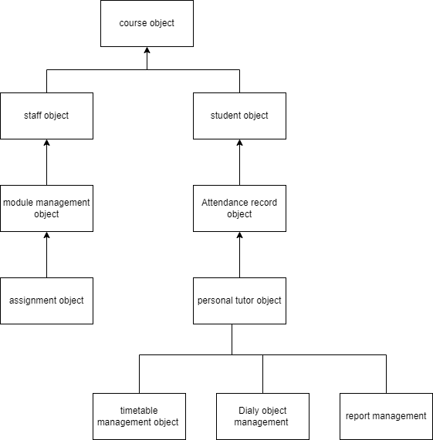

Fig: Bon System Architecture for course management system

The diagram displayed depicts the primary entities and their connections within the course management system. This architectural diagram of the system provides an overview of its structure, allowing stakeholders to comprehend how the various components interrelate.

**3.2.2 BON System Chart**

This chart shows the key objects in the system and their relationships. It helps to define the roles and responsibilities of the different objects.

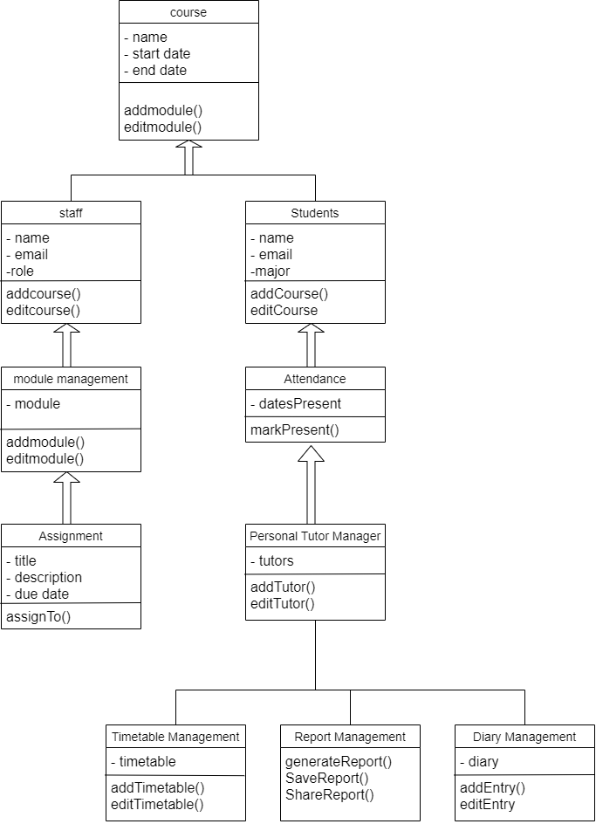

Fig : BON system chart for course management system

The BON system chart shown above offers a more comprehensive perspective on the course management system. It illustrates the various components of the system, highlights the characteristics of each component, identifies the methods or events available for interacting with the system, and describes the interconnections between the different parts of the system.

**3.2.3 BON Cluster Charts**

These charts show how the objects in the system are grouped into clusters based on their functions or responsibilities. This helps to identify the major functional areas of the system.

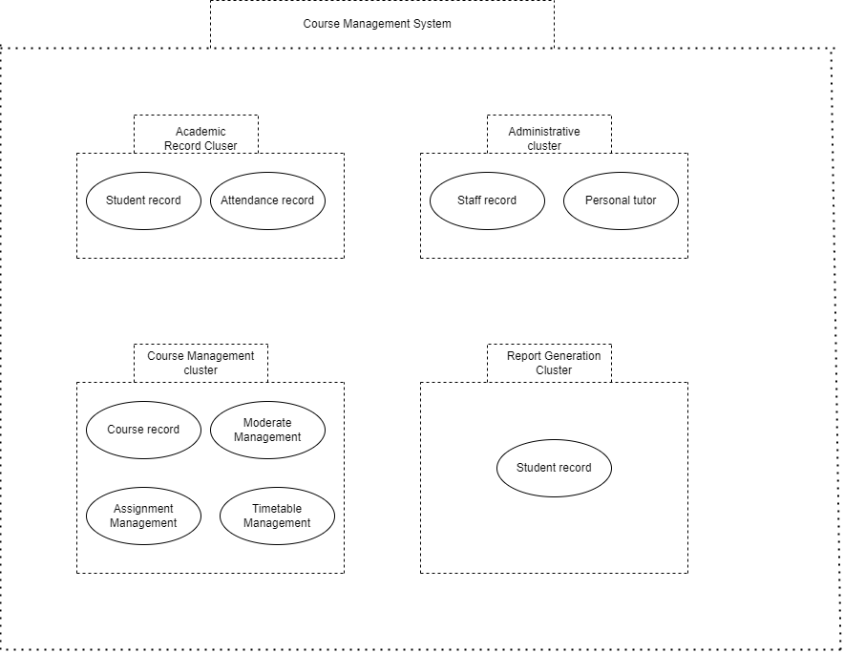

The BON cluster chart displayed above aids in recognizing the course management system's specific areas that may need extra focus, such as clusters that are highly dependent or those with a high degree of complexity. The Academic record cluster and Administration cluster have been identified as high-dependency clusters since they contain vital business objects that are necessary for the system's operation. The Course management cluster has been deemed a cluster with a high degree of complexity because it contains objects with numerous interdependencies and complicated relationships.

**3.2.4 BON Class Charts**

These charts show the detailed structure of the objects in the system, including their attributes (properties) and methods (functions). This helps to define the behavior of the system.

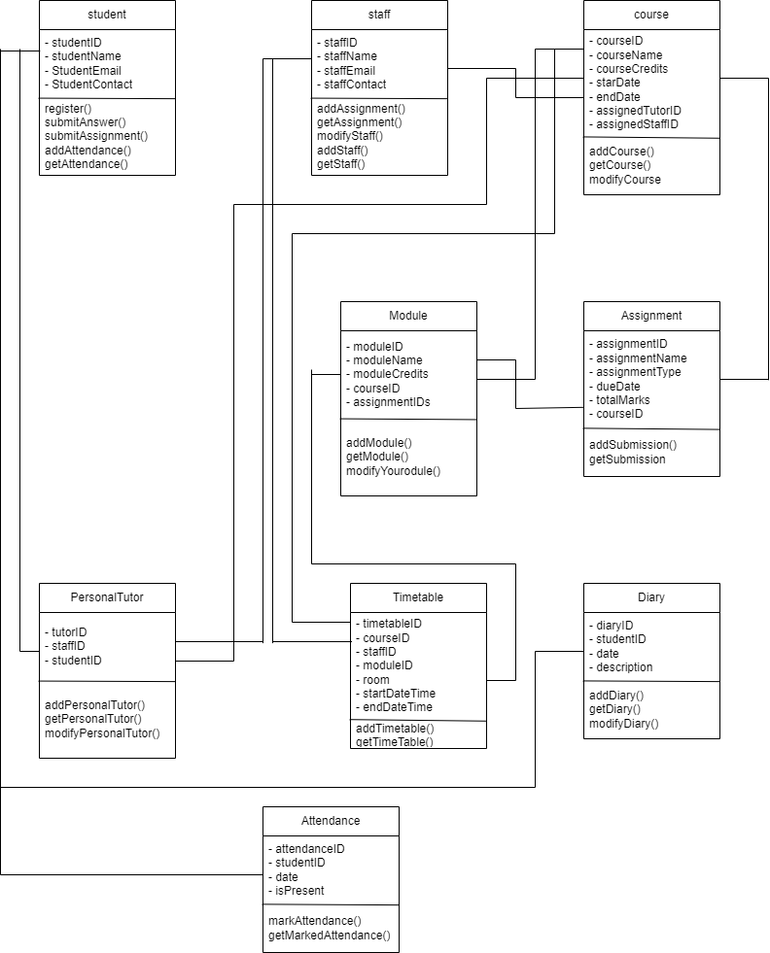

**Event chart**

|  |  |  |  |  |  |  |  |
| --- | --- | --- | --- | --- | --- | --- | --- |
| Event | Description | Start date | End date | Duration | Assigned to | Budget | status |
| Project Management | Establish timeframes and milestones and define the project's objectives, requirements, and scope. | 3 jan 2023 | 11 jan  2023 | 8 days | Project manager | $7000 | completed |
| Configuration of Systems | Design the user interface and the system architecture. | 5 jan 2023 | 22 jan 2023 | 17 days | System architect | $20,000 | completed |
| Designing databases | Create and develop the database's structure and schema. | 18 jan 2023 | 30 jan 2023 | 12 days | Database designer | $10000 | completed |
| Framework Development | Features and operation of the code system | 6 feb 2023 | 6 march 2023 | 30 days | Development groups | $1,30,000 | completed |
| Testing for Quality Assurance | Check the system for errors, flaws, and usability problems. | 3 april 2023 | 18 april 2023 | 15 days | Assurance team | $10,000 | Completed |
| Testing for User Acceptance | Have end users evaluate the program and offer comments. | 15 april 2023 | 20 april 2023 | 5 days | End users | $6000 | completed |
| System Implementation | Install the system on servers for production | 21 april 2023 | 26 april 2023 | 5 days | IT teams | $14,000 | completed |
| Training and Assistance | teach system users how to utilize it, and offer continuous assistance | 1april 2023 | 1 may 2023 | 30 days | Trainer | $20,000 | In progress |
| Project closeout | Examine project results and lessons learned; keep project records. | 1 may 2023 | 6 may 2023 | 5 days | Project manager | $7,000 | In progress |

**Object creation chart**

• Enrollment Record generates objects for enrollment.

• The Payment Record generates the Payment objects.

• Course Material Management generates objects called Course Material.

• The assessment management process produces assessment items.

• Records for grades produce Grade objects.

• Library Management creates Library objects.

• Using feedback management, feedback objects are produced.

• Chat objects are made via Chat Management.

• Notification objects are created using Notification Management.

**System scenario chart**

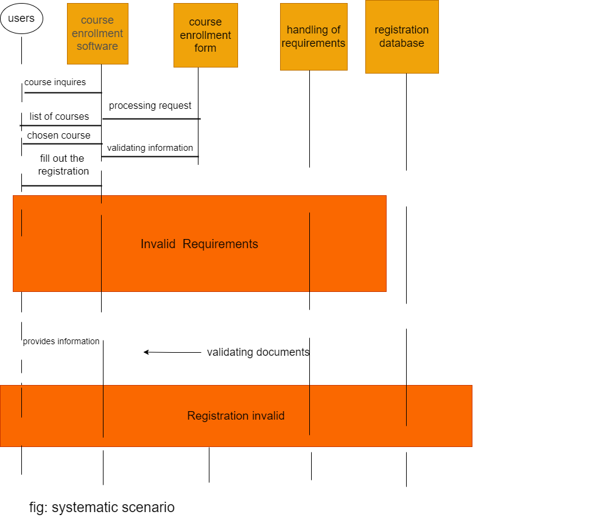

**Dynamic diagram**

4. System Interface Designs

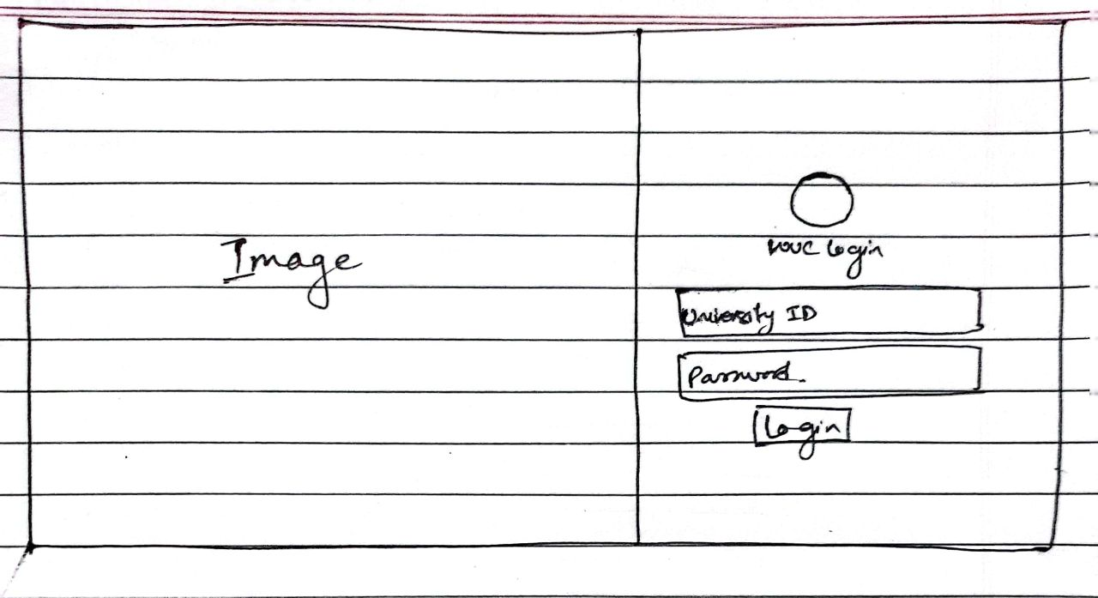

Fig: Login Page Wireframe

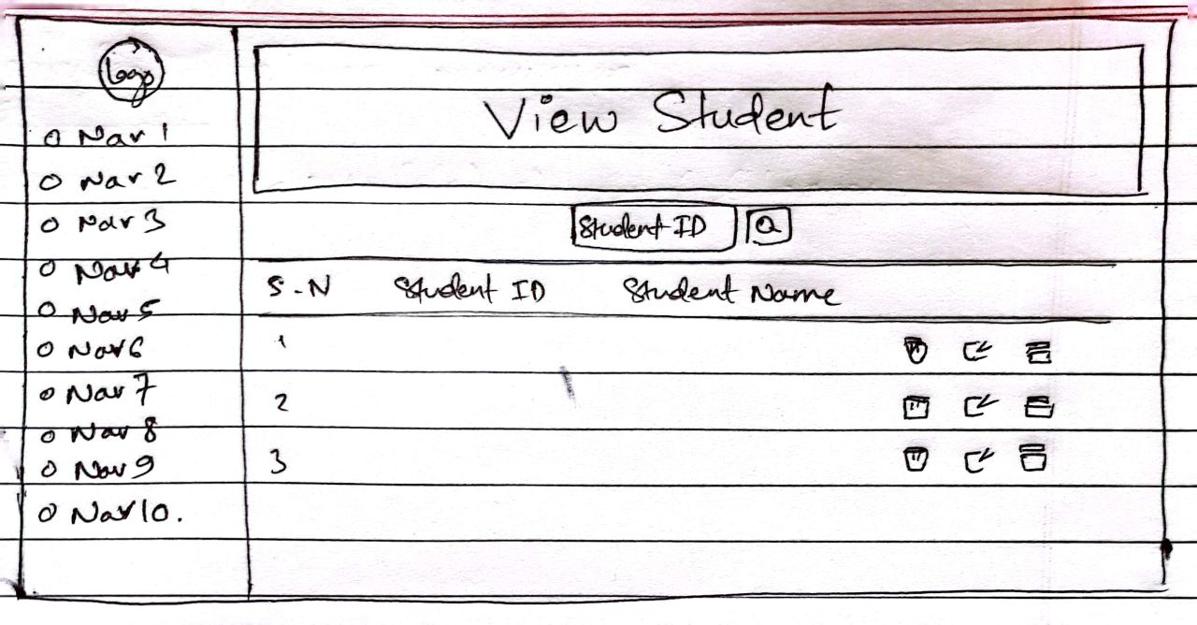

Fig: View Student Page Wireframe

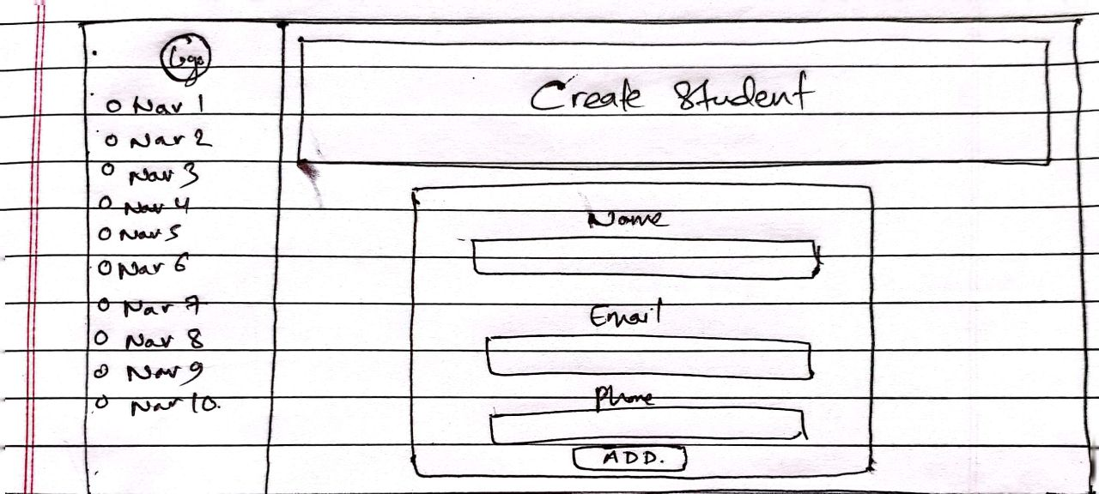

Fig: Create Student Page Wireframe

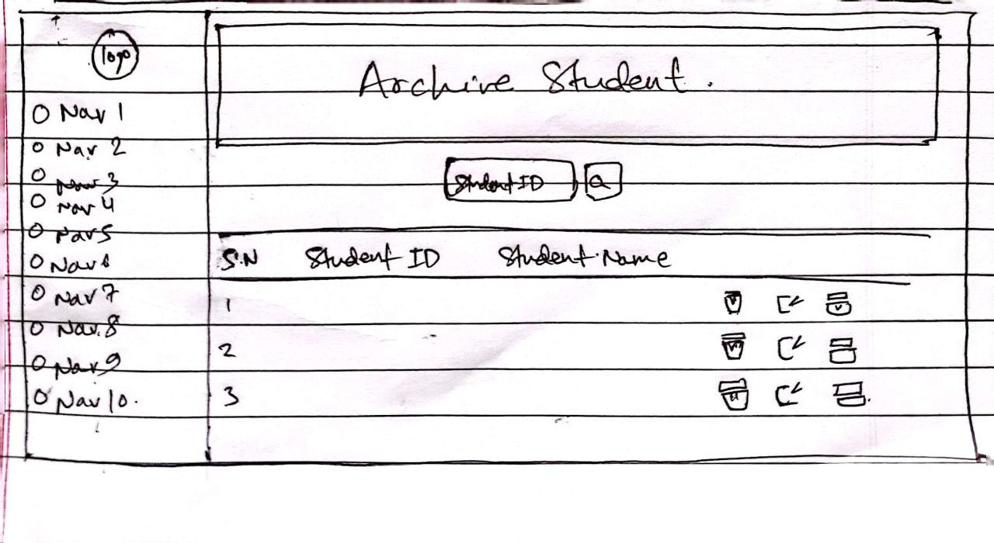

Fig: Archive Student Page Wireframe

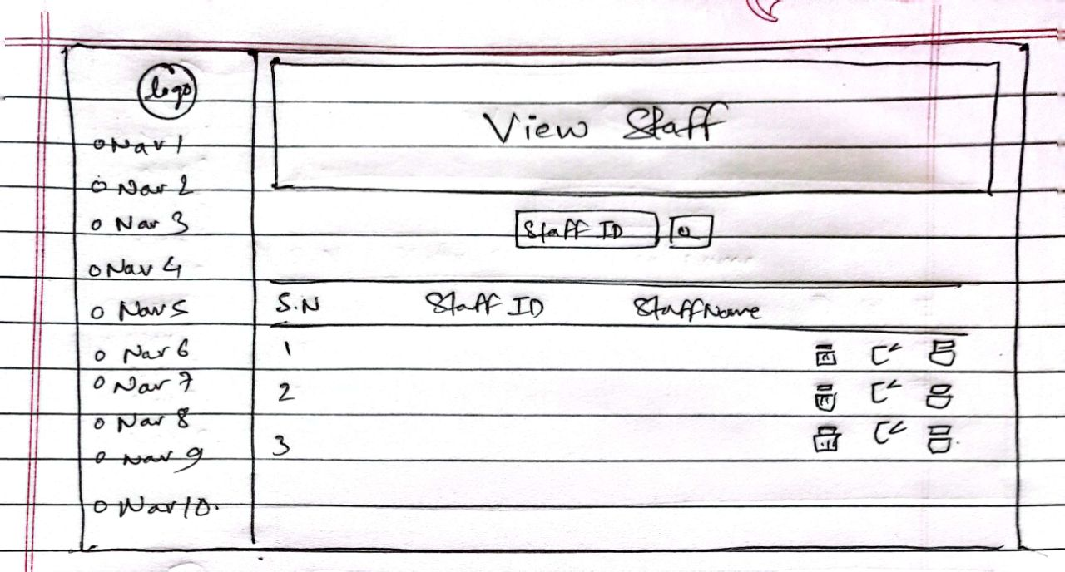

Fig: View Staff Page Wireframe

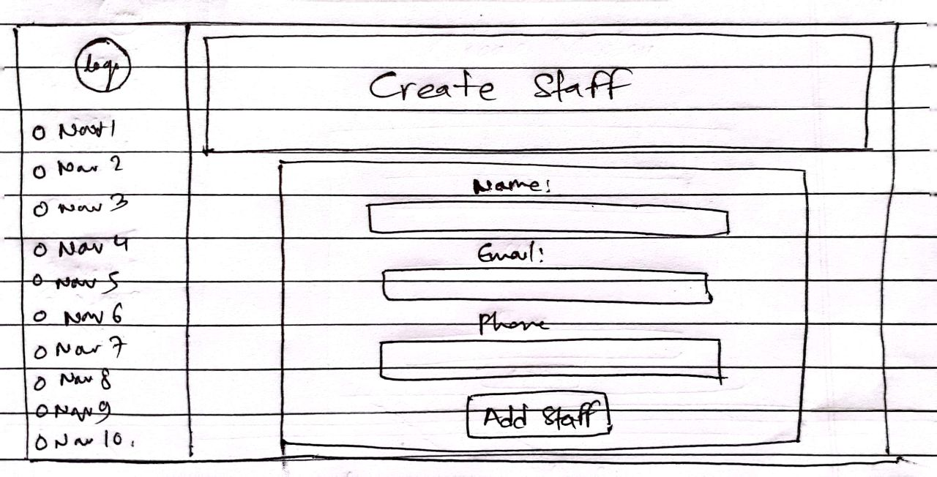

Fig: Create Staff Page Wireframe

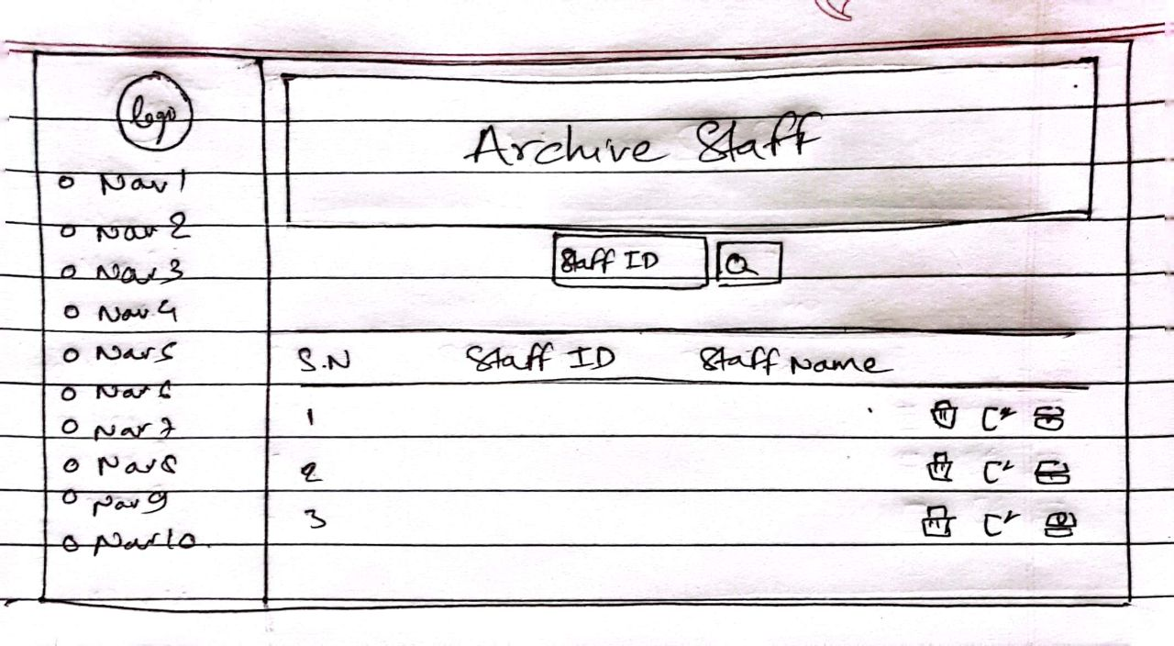

Fig: Archive Staff Page Wireframe

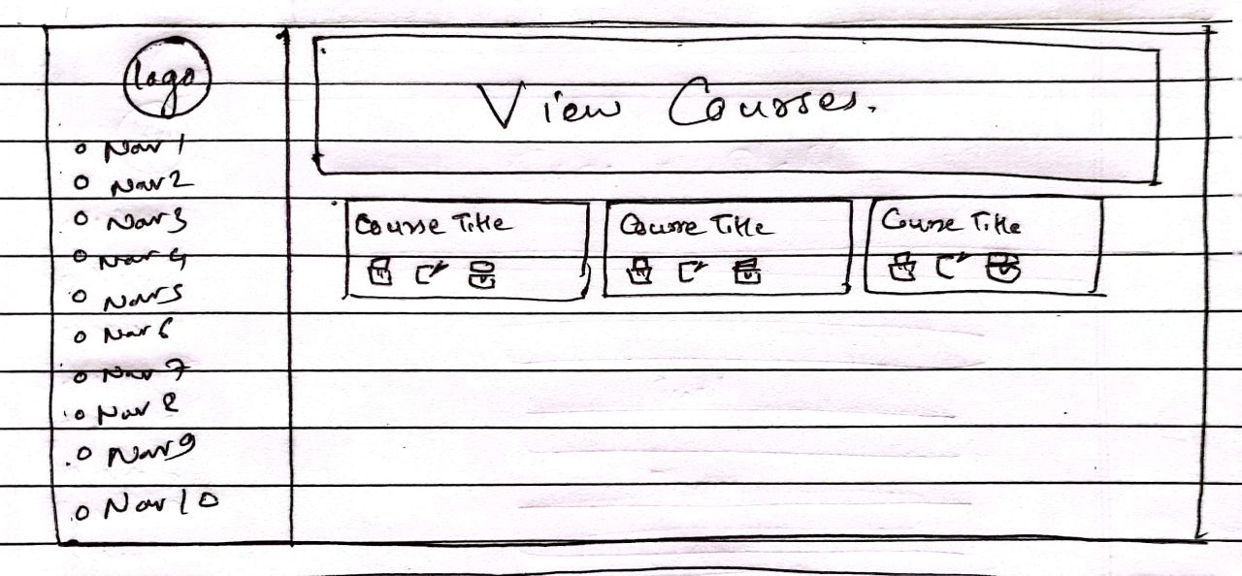

Fig: View Courses Page Wireframe

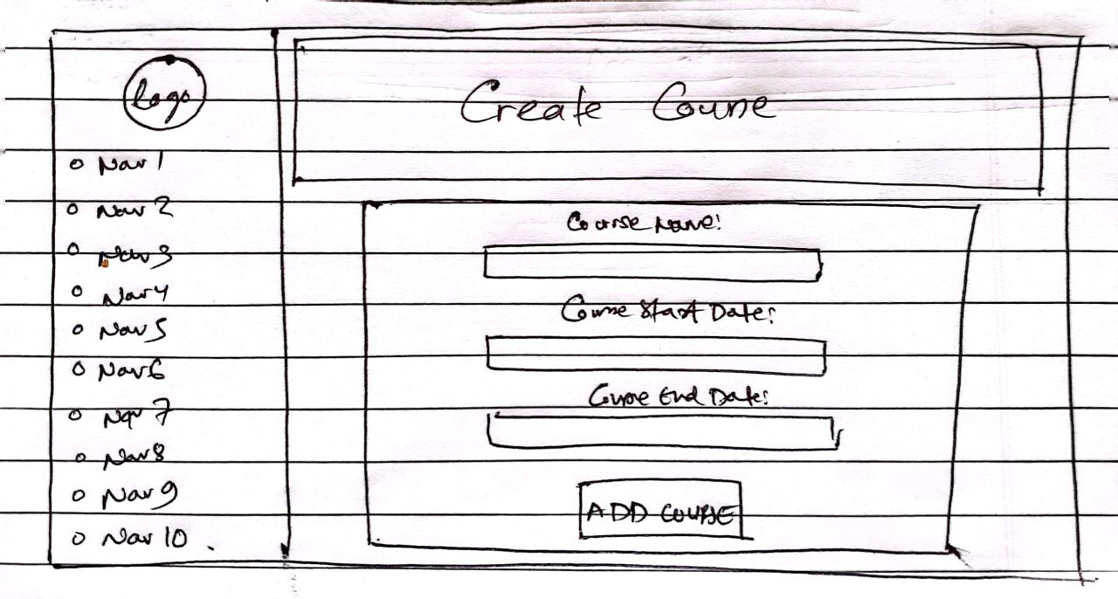

Fig: Create Course Page Wireframe

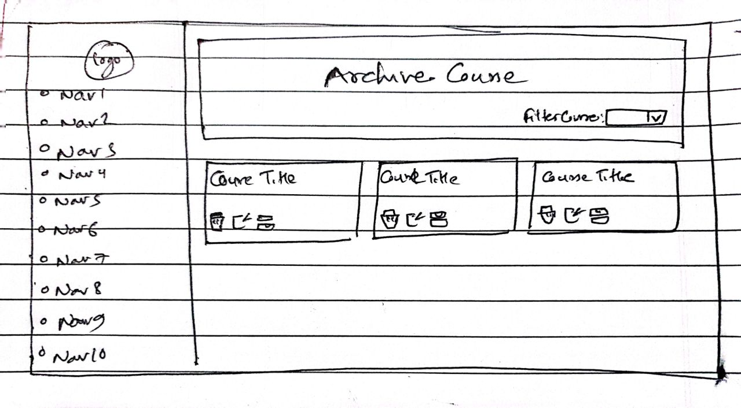

Fig: Archive Course Page Wireframe

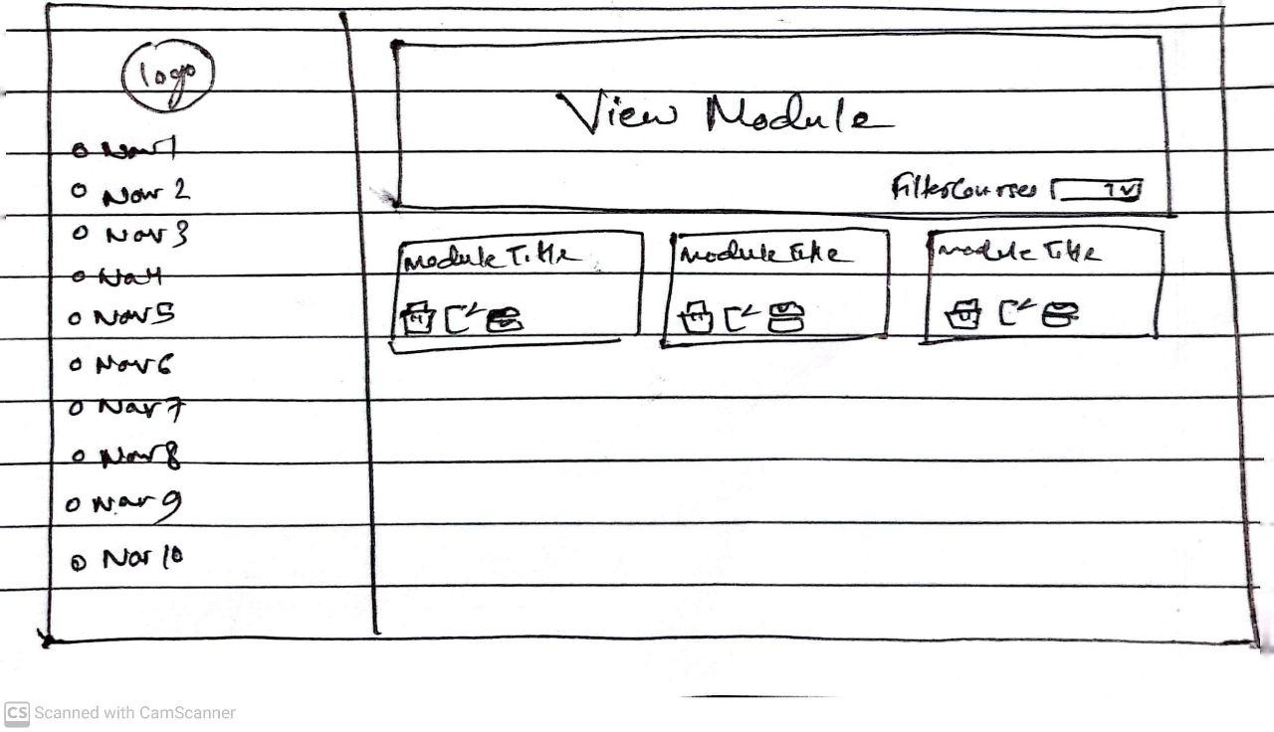

Fig: View Module Page Wireframe

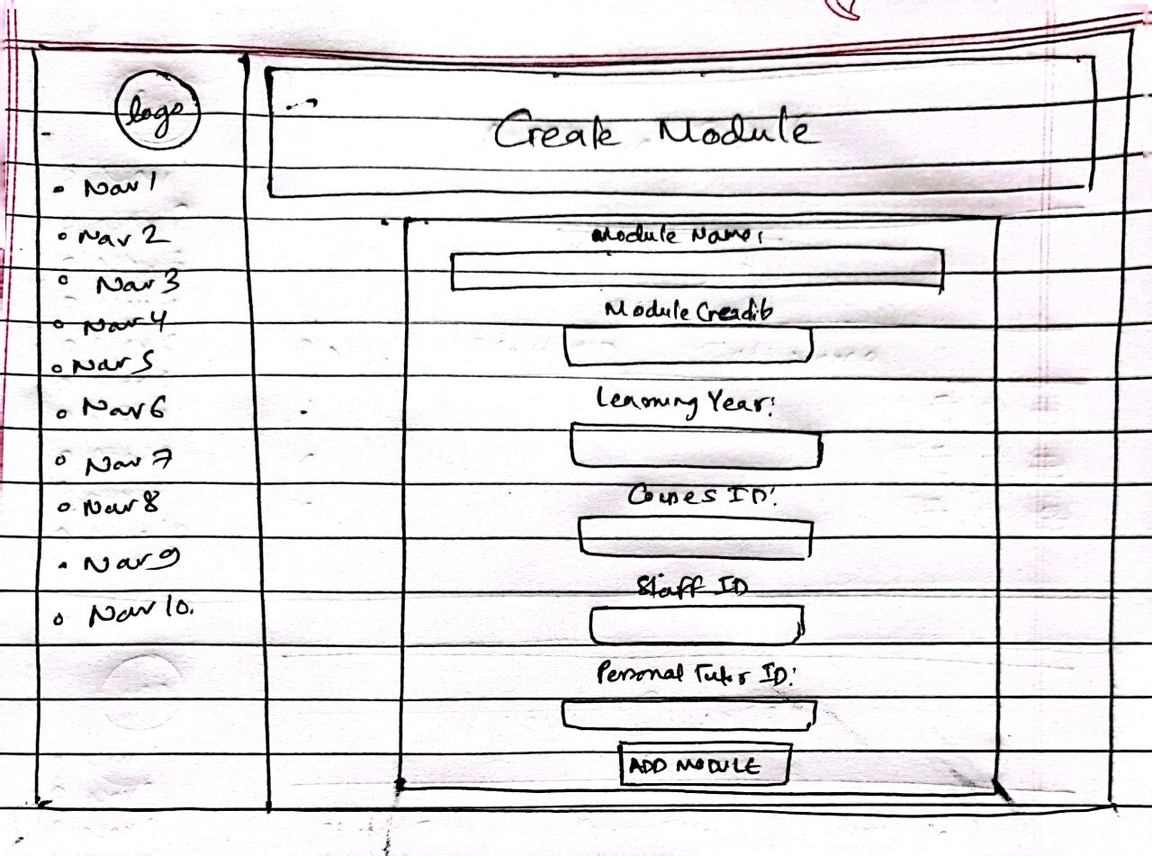

Fig: Create Module Page Wireframe

Fig: Archive Module Page Wireframe

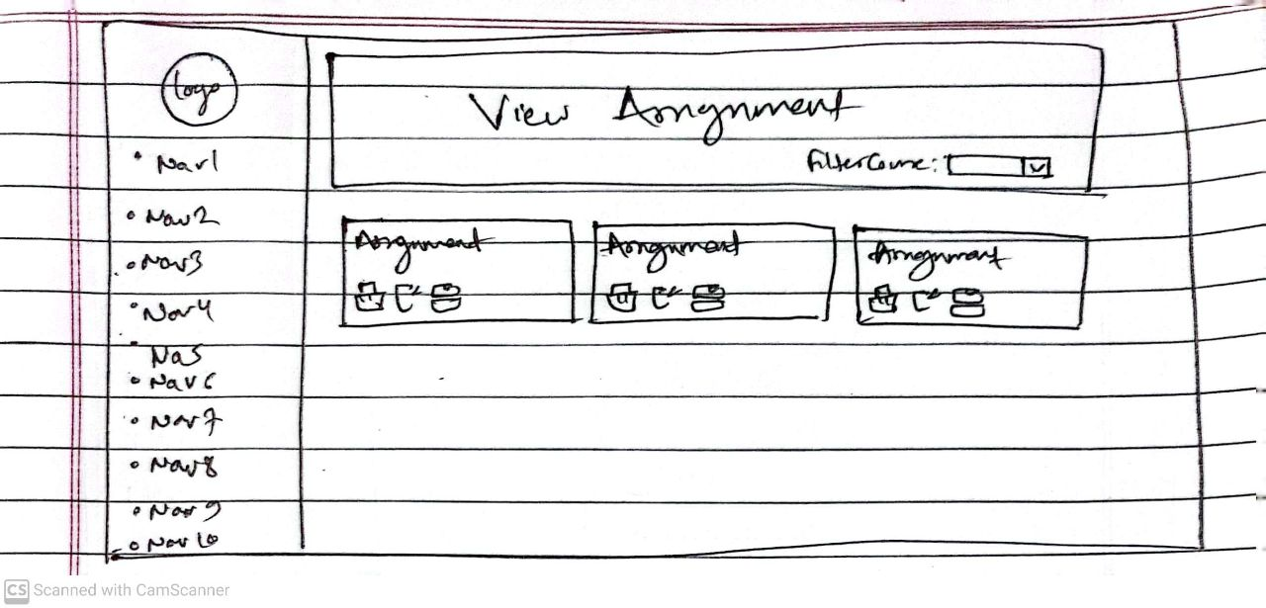

Fig: View Assignment Page Wireframe

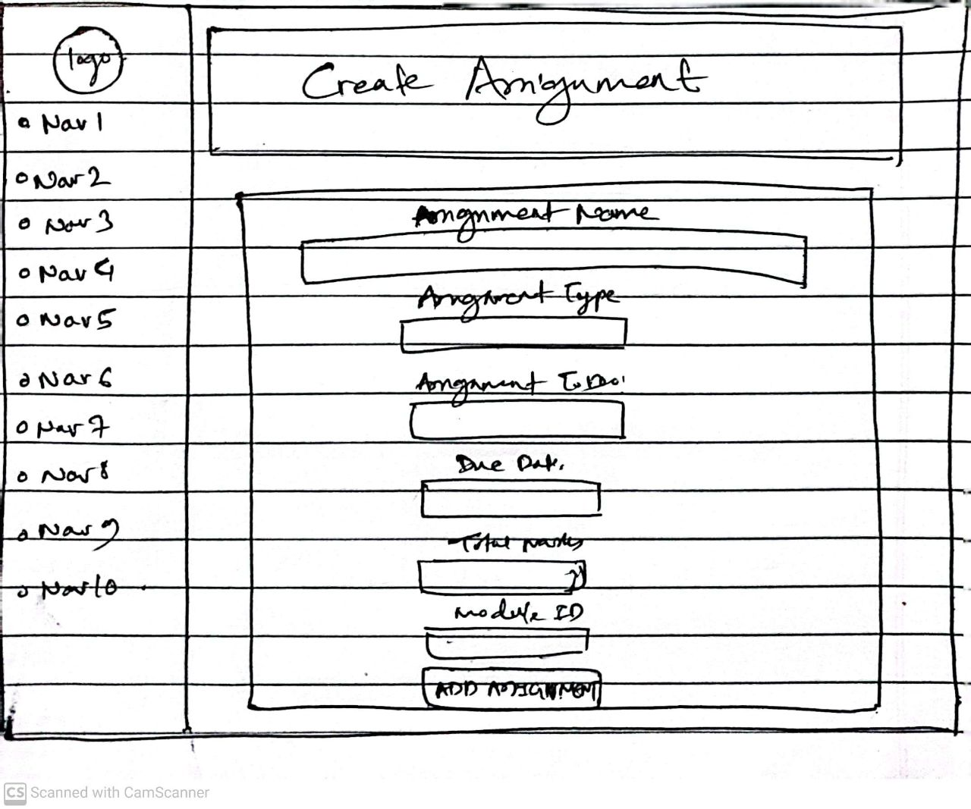

Fig: Create Assignment Page Wireframe

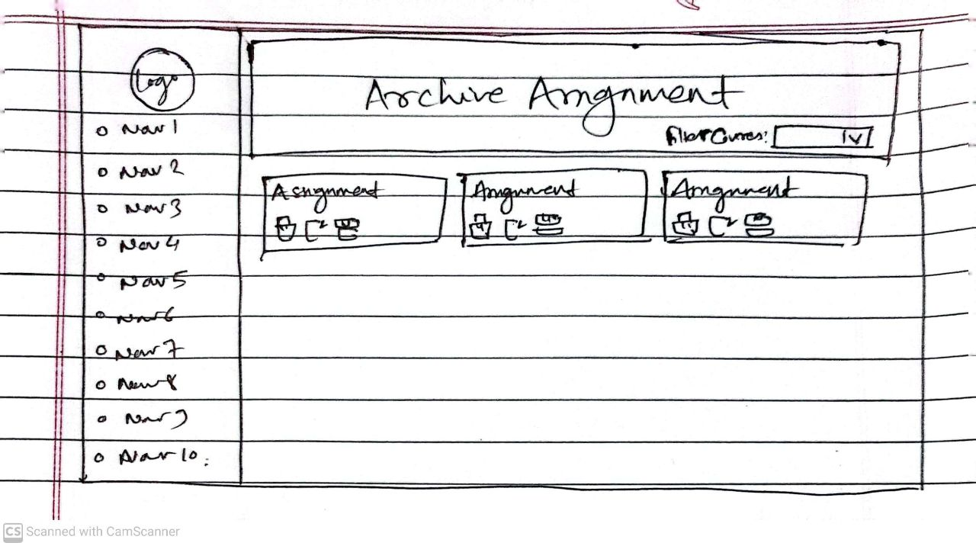

Fig: Archive Assignment Page Wireframe

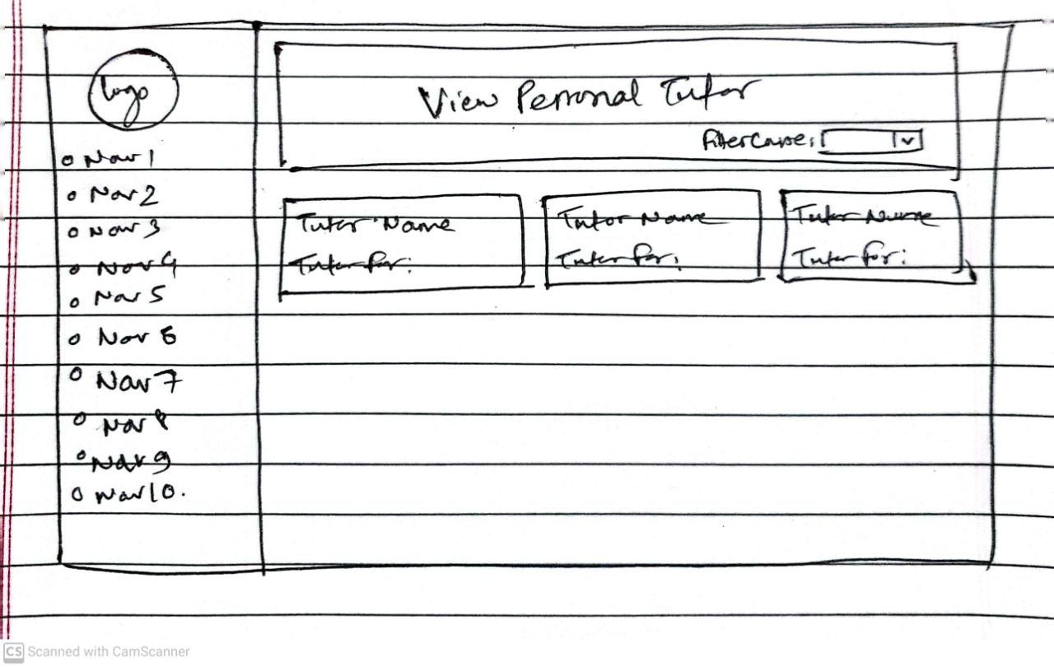

Fig: View Personal Tutor Page Wireframe

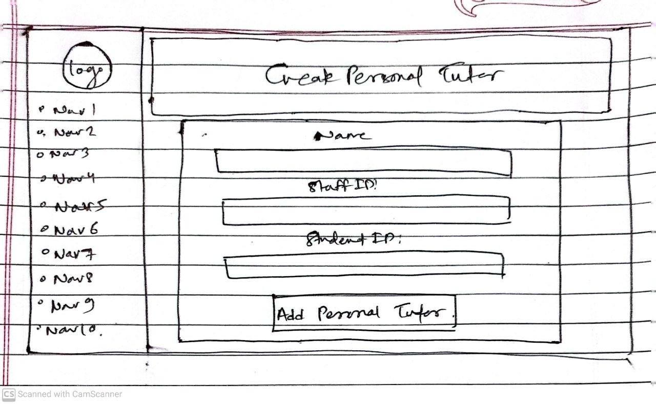

Fig: Create Personal Tutor Page Wireframe

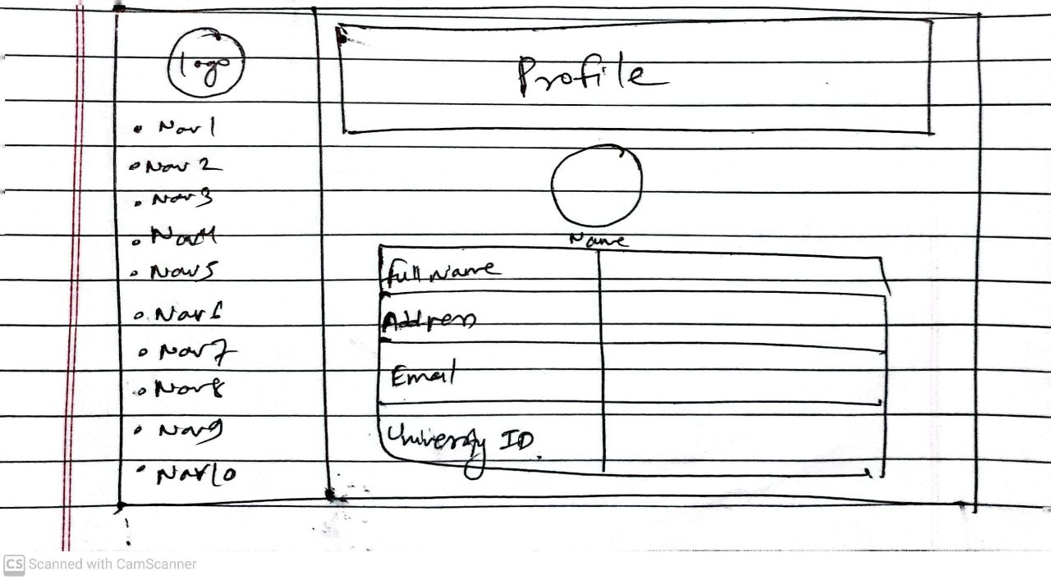

Fig: Profile Page Wireframe

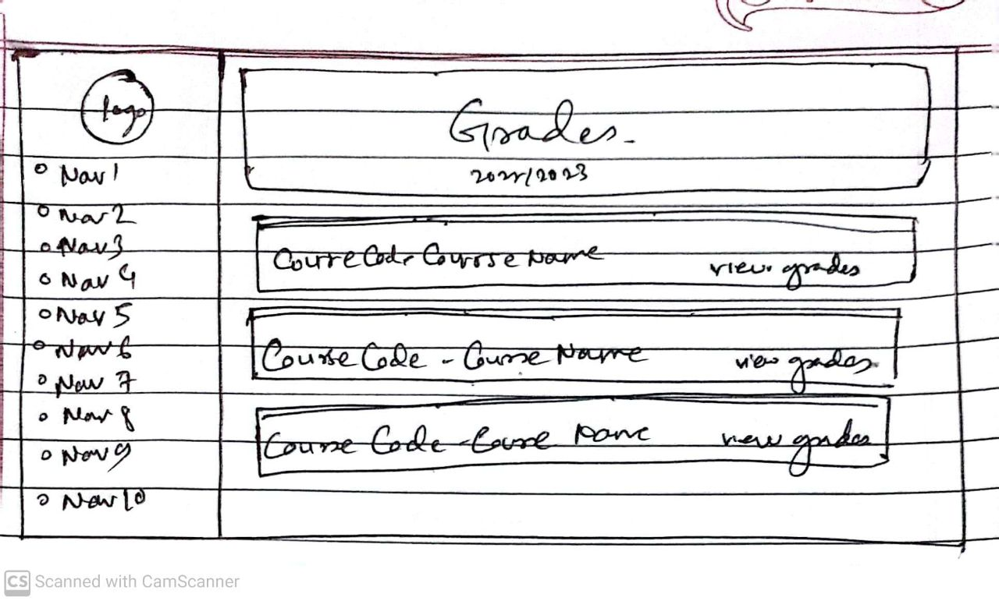

Fig: Grades Page Wireframe

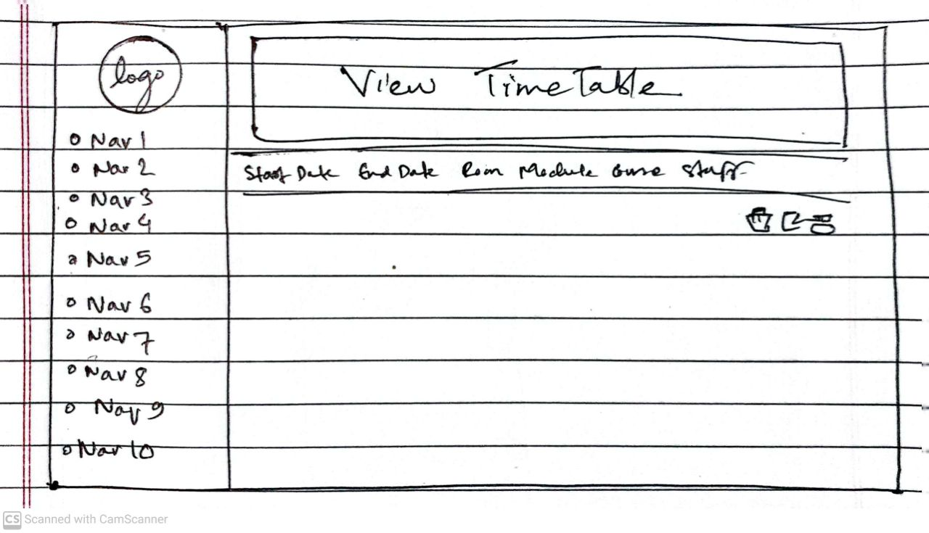

Fig: View Timetable Page Wireframe

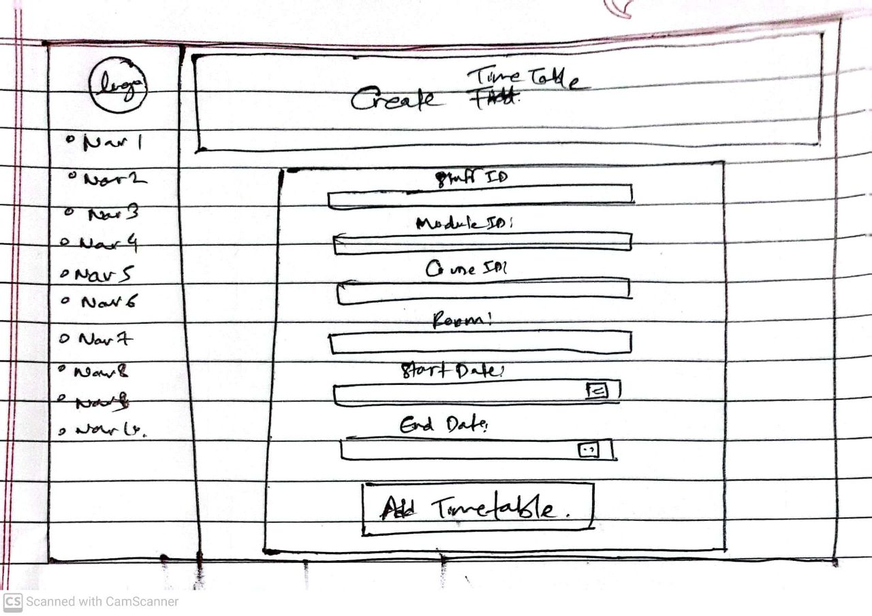

Fig: Create Timetable Page Wireframe

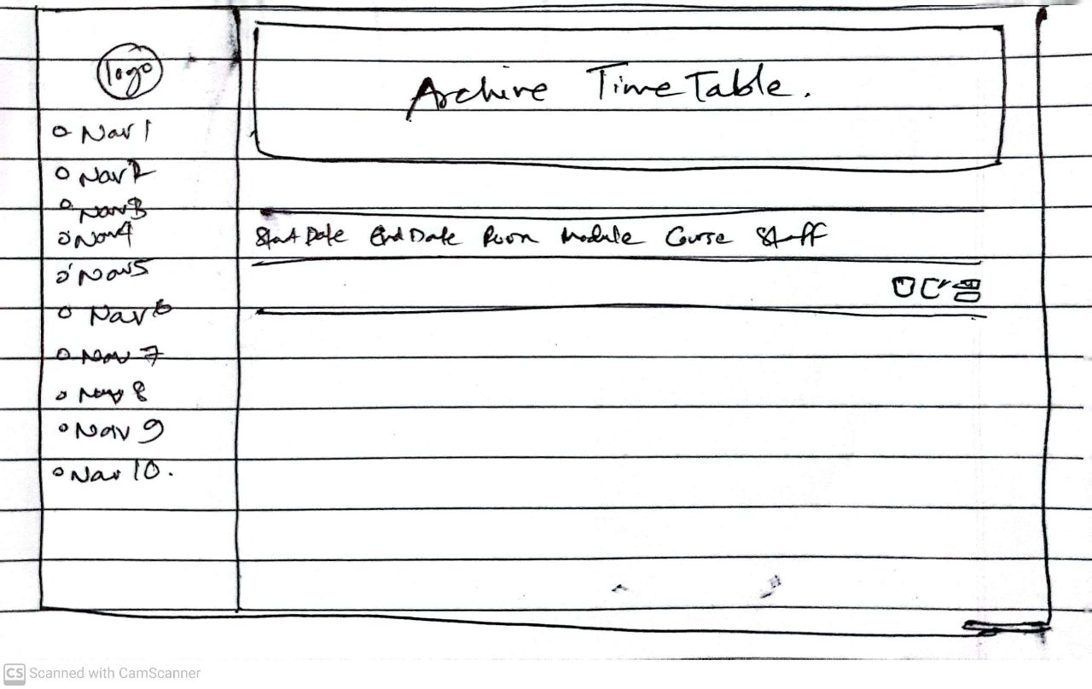

Fig: Archive Timetable Page Wireframe

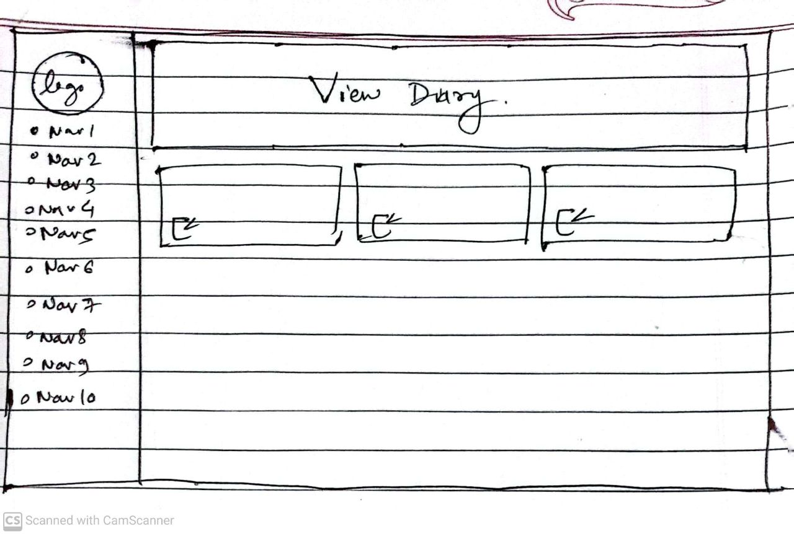

Fig: View Diary Page Wireframe

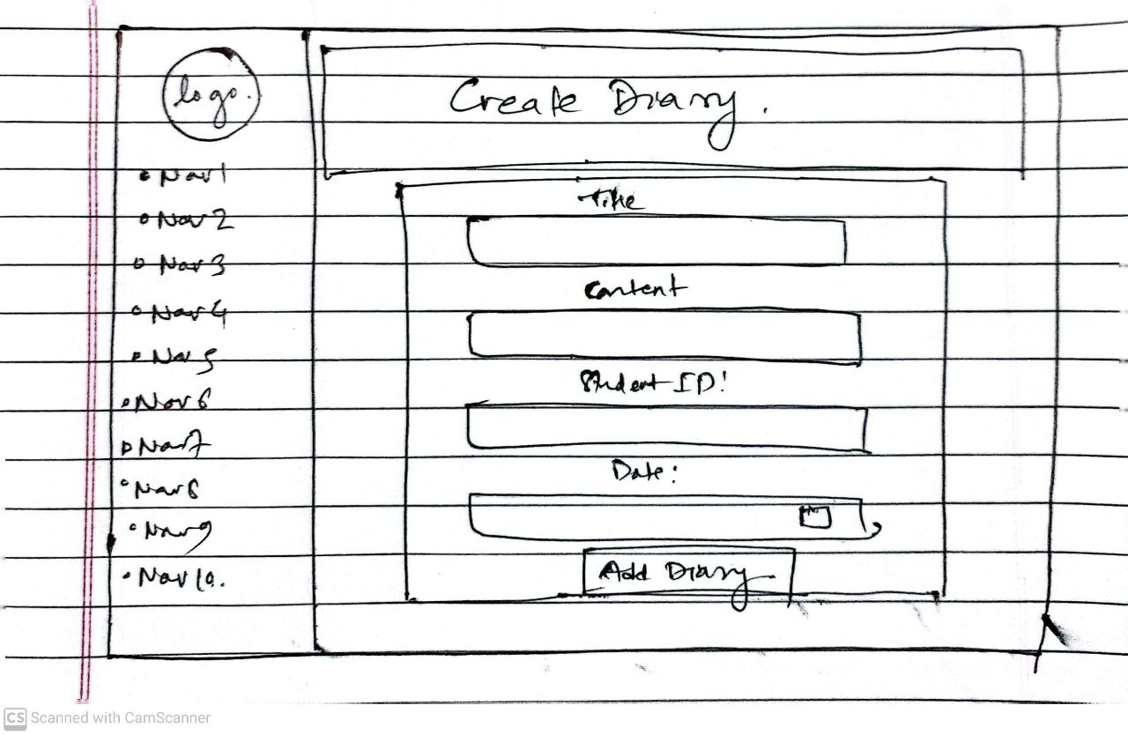

Fig: Create Diary Page Wireframe

Fig: Login Page Mockup

Fig: View Student Page Mockup

Fig: Create Student Page Mockup

Fig: Archive Student Page Mockup

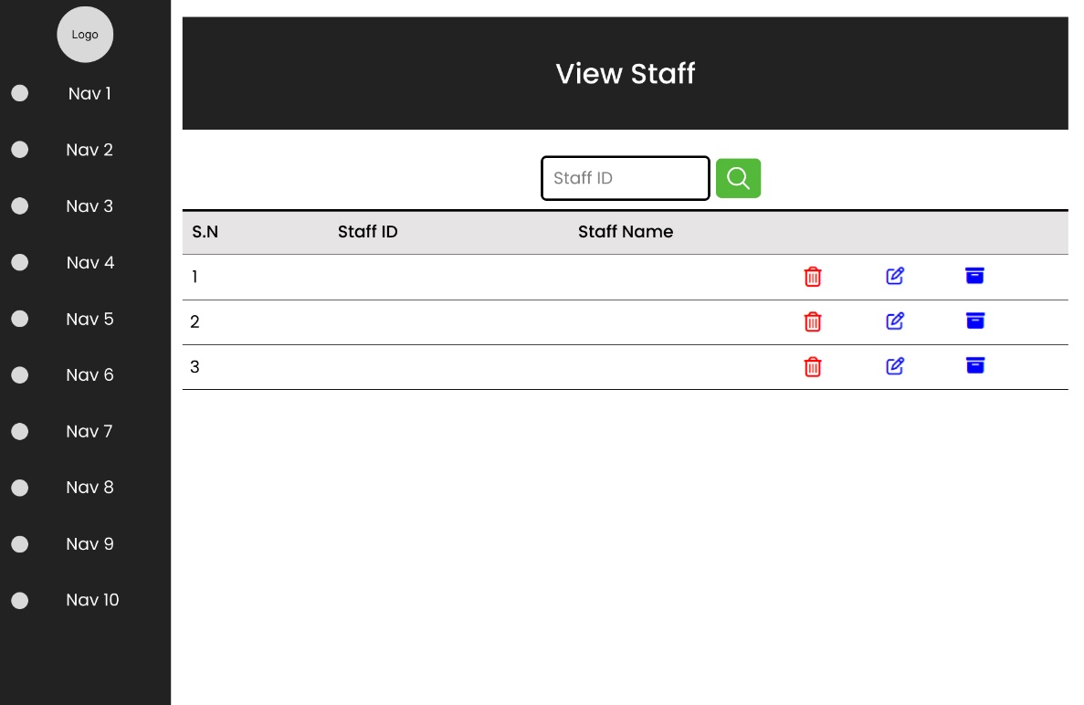

Fig: View Staff Page Mockup

Fig: Create Staff Page Mockup

Fig: Archive Staff Page Mockup

Fig: View Course Page Mockup

Fig: Create Course Page Mockup

Fig: Archive Course Page Mockup

Fig: View Module Page Mockup

Fig: Create Module Page Mockup

Fig: Archive Module Page Mockup

Fig: View Assignment Page Mockup

Fig: Create Assignment Page Mockup

Fig: Archive Assignment Page Mockup

Fig: View Personal Tutor Page Mockup

Fig: Create Personal Tutor Page Mockup

Fig: Profile Page Mockup

Fig: Grades Page Mockup

Fig: View Timetable Page Mockup

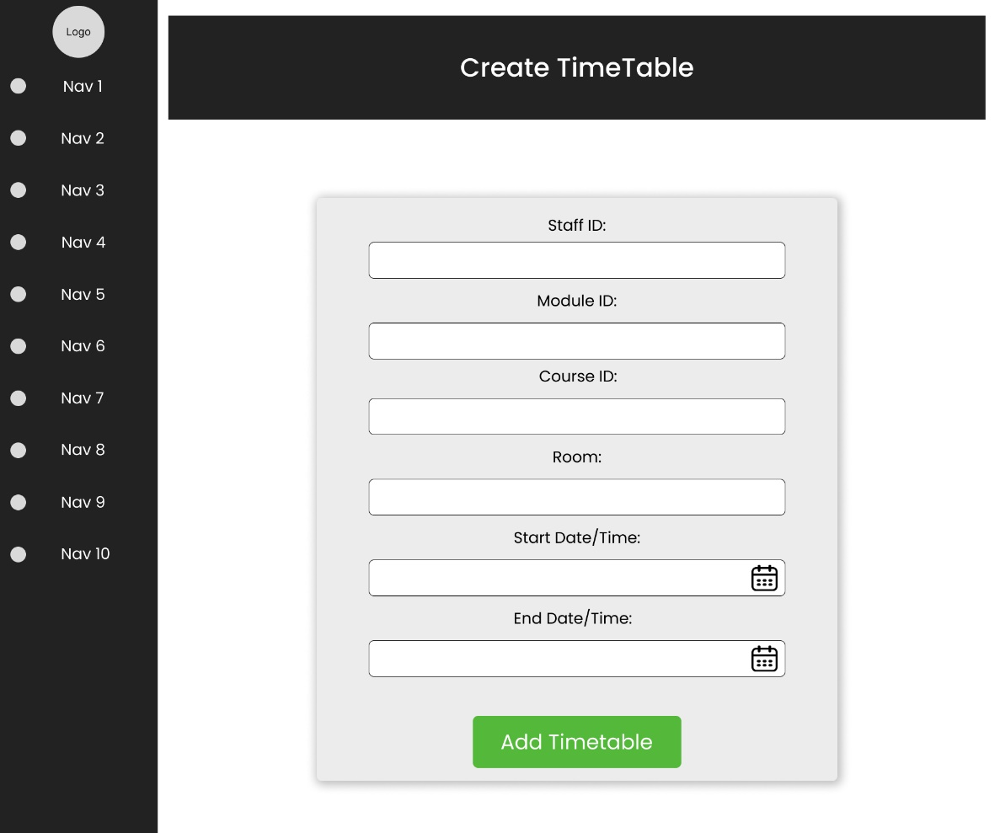

Fig: Create Timetable Page Mockup

Fig: Archive Timetable Page Mockup

Fig: View Diary Page Mockup

Fig: Create Diary Page Mockup